Thursday, April 10, 2008
"The basics are fine."
The other day I overheard a couple people organizing some kind of catered happy hour. The EA (executive assistant) was asking the executive what type of drinks he wanted. It went something like this.
"We could get the fancier drinks like Leinenkugels and Heineken, or we could just get the basics like MGD, Bud, Michelob."
"The basics are fine..."
Of course, you know what I am going to say. In this case (ha, get it), the basics are not fine. Why settle for the basics? Why think it is fine to serve boring run-of-the-mill swill?
It’s ironic to me that even the "premium" options of Leinenkugels and Heineken, while admittedly better than Bud, are still pretty basic. Throw the poor bastards some Sam Adams, Summit, Redhook, Newcastle, Guinness, maybe even some Widmer Hefeweizen. All of those are pretty common and readily found "premium" beers.
One can’t complain too much. The beer selection in the US these days is (dare I suggest) probably as good as you can find anywhere in the world. And we in MN have it better than a lot of places in the US. So I’m not complaining about that. But general beer drinking culture still has a ways to go as far as awareness of what should pass for a decent beer. [side note. is it even further ironic that someone like Miller is perhaps broadening the minds of their swill drinkers by releasing Miller Lite Craft Beer? Perhaps some people will not even have known that there are beers other than the kinds they are used to drinking. http://beersipper.com/?p=34 ].
If people have a chance to try more flavorful beer, and they still prefer swill, then "let them [eat] swill!" But being a strong believer in the possibility of human nature to ascend to unfathomable heights (ah hem), I believe that people, given the chance, will choose taste and quality over flavorless swill. They will not do so, however, if only offered... the basics.

11:51 AM - 0 Comments - 0 Kudos - Add Comment - Edit - Remove

Thursday, March 27, 2008
Asking for Directions tv show
Some of you know Patrick, some don’t. He’s a friend of ours who went to film school out east. He is done now and has made a tv pilot. I haven’t checked it out yet, but I will.
When I saw him last Sunday he was saying this is a travel show, but focusing more on the spiritual landscapes of places, and not just "make sure to see xyz sites."
He is interested in any feedback, preferably brutally honest. So if you are inclined, let him know what you think, and forward the link to anyone you think would be interested.
http://www.askingfordirections.tv/
12:04 AM - 0 Comments - 0 Kudos - Add Comment - Edit - Remove

Thursday, March 20, 2008
Things that make me go Hmm, Part 2: God and Sports
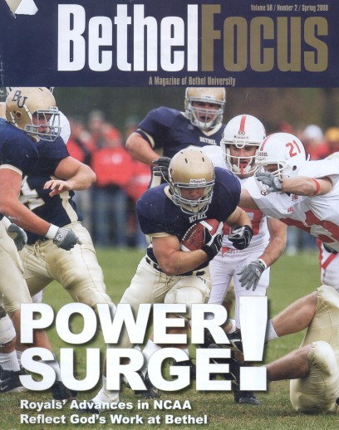
This post will talk mostly about sports, but you can apply it to any number of things that you might question how much God cares about or actually has an influence on.
Above is the cover of the most recent Bethel alumni magazine. Notice the lower left, "Royals’ Advances in NCAA Reflect God’s work at Bethel." After reading this, I knew I was in for a doozy of an article.
"Extraordinary performance has attracted a new level of visibility for Bethel athletics... and the notoriety has helped tell the kingdom story that is tightly woven into the entire athletic endeavor at Bethel University." I suppose this in itself does not assert that God has helped the athletics thrive, but you do not have to read far between the lines to realize that the article supports this idea. We have a good Christian school made up of Christian kids, God has rewarded those in sports with success, and thus the school has a greater and more vast appeal to the general public as well as future students.
And it makes me wonder, does that follow? Has God in any way been at work in Bethel’s athletics becoming more successful over the last ten years? The article points out other significant factors such as good recruiting, effective coaches, hard working kids, and rounded off by a solid academic base in the students playing sports. Oh, need I mention the many athletic field and building improvements? The weight room being remodeled? A new football stadium? New baseball field, tennis courts, and I’m sure more. Maybe all of that, plus the above, has something to do with the athletic success and growth?
Well maybe, but don’t forget how much God wants them to thrive so the story can reach a wider audience.
This kind of thinking, I don’t get it. Even during my Bethel days when I was more traditionally Christian I would have thought this was lame. I believe God cares about people and wants them to interact with him (or if you like, her). But come on.
One more choice quote from one of my favorite (ah hem) old Bethel people. Judy Moseman "maintains the maturing process in student-athletes acts as a ’salty influence’ for the rest of the campus." If she is talking about the student-athletes after they are done practicing, when they are good and sweaty, then she is, for once, right.
9:27 AM - 1 Comments - 2 Kudos - Add Comment - Edit - Remove

Wednesday, March 19, 2008
Brewing Documentary posted on YT for y’all
I finally got a dvd of The American Brew, a 50 minute documentary on brewing in America. After the countless hours of reading, discussing, listening, and actually doing things related to beer, this documentary comes off as more of a very brief summary. Still, it is well done and if you like beer and beer history, you can check it out. I posted it on YT and so far it is still up.
It is in 6 pts and to see all of them you should go here: http://youtube.com/user/donosborn
I’ll throw up a link to the first part though: http://youtube.com/watch?v=8k-A2iaawTE
Here are a few thoughts. I was pleased to see a section on homebrewing in the relatively short documentary. They put up a stat that 500,000 Americans brew their own beer, and they spend a few minutes with a guy in New Jersey who is making a Trippel in his (small?) apartment. In the background you can see many ribbons that the guy has won in competitions, and it is fun to take a look at his fermenters. (Question, is this dude married?! I thought I saw a family pic but what wife would let him use a room in a small apt for his fermenters?)
But what was really more interesting to me was the "Extras" section, which is basically as long as the main film. The Extras are in 5 pts and here is the first part: http://youtube.com/watch?v=Srvu6dz2MtM
In the Extras Maureen Ogle (author of the great book Ambitious Brew) is allowed time to explain why we actually got light tasting beer. It wasn’t top down, but bottom up. That is, brewers were trying to come up with a drink that the typical American would like, after prohibition. They had forgotten about beer with full flavor, and began liking a lighter beer, thus forcing the brewers to brew that kind of beer to stay in business.
There is more discussion on homebrewing in the Extras too including more with homebrewing Godfather Charlie Papazian.
It was really great to see more interviews with the late Michael Jackson, the preeminent beer critic and author, and all around swell guy. He had Parkinsons and you can see a little bit of that in this video, however, it was not as developed as later in life and as in other videos I’ve seen of him. To hear him describe a beer as being good at bedtime, especially if the rain is hammering at the window pane, well, it was priceless. He will be missed.
~ 6:20 here: http://youtube.com/watch?v=yFh9gIF5KDs
There is a nice section of what Garret Oliver calls Cheese Wars. He and a wine sommelier pair off in front of a group, and take turns having people try different cheeses with either wine and beer. I have listened to these before and it is fun to see it in action. It’s all about getting the word out, beer is infinitely more complex and flavorful than a lot of people believe.
Another cool thing was to see a bottle of Schlenkerla being poured, and discussion of smoked beer and smoked cheeses. I love me some Schlenkerla! Smoked beer is not for everyone but if a couple people like it who have never tried it, that means more business for this small Bamberg brewery and more awareness of the style, which hopefully means it will be around ever longer! A bit of a tangent but so it goes.
So, if you are well versed in beer history, at least check out the Extras.
9:38 AM - 3 Comments - 3 Kudos - Add Comment - Edit - Remove

Monday, March 17, 2008
Friggin Firkin Fest - cask ales under a tent at the Happy Gnome
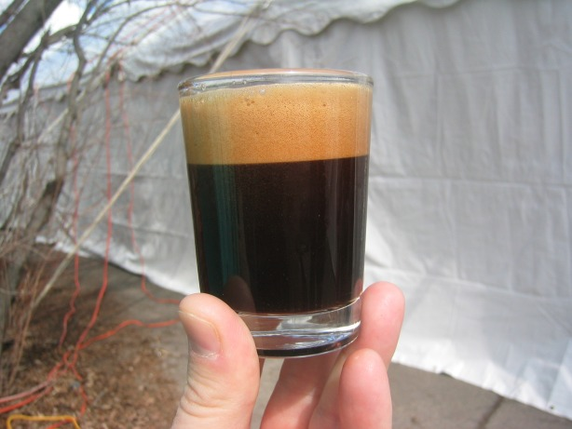
Here are the details:
http://www.donosborn.com/firkinfest/firkin_fest.htm

11:26 AM - 0 Comments - 0 Kudos - Add Comment - Edit - Remove

Thursday, March 13, 2008
Things that make me go Hmm, Part 1: Missionaries
As some of you know I have been doing a lot of thinking, reading, discussing about, and revising of my theological and political beliefs over the last few years. I thought it might be fun to post a few thoughts here. I don’t plan on getting too detailed - that kind of thing is perhaps better left to face to face discussions with friends, usually accompanied by a good homebrew.
For the first installment let me talk about missionaries, specifically those who travel to distant lands, perhaps even to primitive cultures, with intentions of bringing them the gospel of Jesus Christ. I had this thought when reading about Wycliffe Bible translators. The organization was founded after visitors to the Cakchiquel Indians in Guatemala learned that the tribe expressed surprise and concern that God did not speak their language. This prompted the visitors to form the organization that would work to translate the Bible into as many different languages as possible, so the ignorant natives can have the proper information about who God is and how to experience him.
How sad is that? Some Westerners traveled to this tribe (I give them credit for their adventurous nature, at least) only to tell the tribe they are wrong? Have we not heard this before? If you grew up in the church hearing missionary reports, you have.
Many times I have heard stories of native people saying things like "how grateful we are now to know that we were worshipping the wrong God. Now we know of Jesus and his love for us, and are able to read the Bible in our own language. God has saved us from hell and now we know the truth." I’m paraphrasing but that is an adequate summary of things I have read and heard growing up. I am also kind of mixing the ideas of Bible translation with missionary work, but admittedly they are related.
Who the devil made these missionaries God? Is it not the epitome of arrogance to say to someone "your version of God is wrong; you must adopt our view or be dammed to hell"? Growing up I would have praised the missionary’s bravery and soul-saving passion. Today I find it condescending and hurtful.
Who has a monopoly on God? Why do so many established religions put God in a box? If different people groups all over the world have enjoyed their unique vision of God over the centuries, why should one people shame, deride, even make war upon another group for theirs?
These are not new questions, obviously, but what was new to me this morning was viewing Christian missionaries this way. I’m sorry if any reader of this is put off by this view, but maybe our God can forgive me.

10:54 AM - 2 Comments - 4 Kudos - Add Comment - Edit - Remove

Tuesday, March 04, 2008
Even Conservative Talk Radio talks about Craft Beer
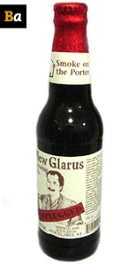
Each morning in the kitchen I turn local talk radio. It happens to be one of the more conservative talk radio stations in town. I listen not for the politics (any longer), but kind of out of habit and also for the frequent news and weather updates.
This morning they started talking about different beers and my little ears perked up like a deer in a field hearing a noise. They were mostly talking about how much they don't like the big breweries attempts to market lime chill beers, or this new Chelada beer by Budweiser, a clamato infused monstrosity.
But then the conversation shifted into more negative general stereotypes. (I know, on conservative talk radio?!) That conversation mostly consisted of lambasting fruit beers, like Leine's Berry Weiss, but also took shots any any beer that "requires" it to be served with fruit. They mentioned Blue Moon with an orange or Leine's Honey Weiss with a lemon. [Do they not know they could refuse the fruit if they actually liked the beer?]
But my friends, the air is different today. We have all heard these types of conversations over the years, but today was different. Jay Coles (who was also deriding the beers served with fruit) said he does like "normal" craft beers. I will try to quote from memory. "For example have you had New Glarus made down in New Glarus Wisconsin? Every now and then they let the brewer go crazy and combine recipes and just make one unique batch for that month. They call it the Unplugged series. The one he has out now is called Smoke on the Porter. [at this point I am standing still in my kitchen not believing I am hearing an awesome New Glarus Unplugged beer talked about on the radio]. It's a strong Porter beer, ok, but he makes it by smoking the barley malt over wood, so it gets a very nice but smooth smoke flavor in it, and it's just awesome."
So, there you go. That is pretty sweet. More than a plug for New Glarus I think that it just shows that ever more each year, the general populace is starting to dabble in craft beer and finding a lot to like in beer with flavor.

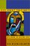 | Currently reading :  Jesus Against Christianity: Reclaiming the Missing Jesus  By Jack Nelson-Pallmeyer  Release date: 01 July, 2001
9:51 AM - 2 Comments - 2 Kudos - Add Comment - Edit - Remove

Friday, February 29, 2008
Teaching the People about Beer
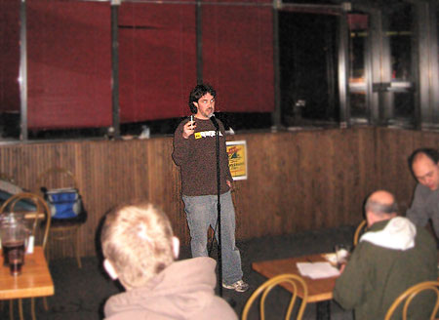
Photo from: http://mnbeer.com/2008/02/28/stub-herbs-beer-tasting-recap/
About a month ago I first heard that the manager at Stub & Herbs was looking for a homebrewer to help with some beer education events. I talked with Jon the Manager and it sounded like something I would like.
The first event was the other night. There was a brewery rep from Sierra Nevada. He passed out pint glasses, bottle openers, and some literature. He talked about their brewery and beers for about 15 minutes. Pitchers of Bigfoot Barleywine, ESB, and the never-failing Pale Ale went around. Then he left the stage.
This is where it got interesting. Jon had anticipated a slow, normal quiet Wednesday. He did not count on high-school hockey games (at the Gopher hockey arena?) that brought in tons of people. It was difficult to even get to S&H, let alone park. Once inside, it was nuts to butts. Jon was completely swamped and busy pouring beers, cleaning tables, and as he said later "opening tons of bottles of Miller Lite."
In the adjacent room, however, I felt something needed to be done. The stage was empty and the people wanted beer. I knew Jon wanted me to speak for a little while about a couple of beer styles as well as talk briefly about homebrewing, so, well, I took over.
I first talked about the style of Barleywine, asking questions of people, comparing them to the cattle that run towards the truck of Sierra Nevada spent grain once it is delivered to the farm, trying to loosen everyone up and set the tone, trying to keep it low key and fun. I was making jokes and getting them to call out descriptions of the beers we were tasting.
It ended up being really fun. After Barleywines (Sierra Nevada, Flat Earth), I sent around my Steamin' Wife Lager homebrew. I got a number of positive comments on it at the time and even more after the event was all done. That was encouraging.
Then I talked briefly about the style American Pale Ale. I had passed around sheets with info on these styles as well. We sampled a few different pale ales and talked about them as best we could in a room with 25+ people right next to a room of loud revelers.
I ended up being on stage for around an hour, maybe just over. I had the realization at the time that if I believed that I was funny and interesting, I was. I have not done a lot of training or teaching (only some) and this was a new feeling to me. I mentioned it to my wife and she said, yeah of course it is like that. She's a teacher who has taught in inner city Minneapolis schools. You have to be confident, and that will carry the room.
So I ended up doing a lot more than I think I was originally asked. Jon was very appreciative and of course I understood his situation. People seemed to enjoy it, and I talked to two different people who are interested in starting to homebrew. Of course, I directed them to Northern Brewer as well as the brewing guides on my website.
The next one is supposed to be the last Wednesday of March. If you're free, come on down.

11:20 AM - 4 Comments - 5 Kudos - Add Comment - Edit - Remove

Wednesday, January 16, 2008
To the Person Whose Car I Just Hit with My Hand....
Current mood: ashamed
I'm sorry. I think I have a problem with impatience. There I was, walking to work in the morning, just cruising along with a "walk" sign and a green light, and you come whizzing up to the stop light (red, for you) wanting to make a quick stop and then turn right on red, and in your haste you almost hit me.
I'm sure you were in a hurry. I'm sure you have good reason to be looking at the oncoming traffic and not seeing pedestrians in the cross walk. So, I'm sorry I smacked the back of your window with my gloved hand.
And then you pulled over (did I not see that coming? d'oh) and asked "hey man why are you hitting my car?!" And I said "you almost hit me!" And you responded "I didn't f--king see you!" At least you were not aggressively attacking me, which I am thankful for.
So why did I smack your car? How much time do you have? The first and most immediate reason was out of frustration. I am frustrated with people's careless, selfish, even reckless driving. I am tired of it when I am driving. I am tired of it when I am biking, which is the majority of the time. Sh!t man, I am even tired of it when I am merely a walking pedestrian. So, I lash out in my own little way and that smack is me saying "hey morons of the world, watch the f--k out for other people, someone outside of yourself, if you can manage to entertain that notion for one friggin second."
Next, I'm tired of the hectic pace of life, people buzzing in and out of downtown, in and out of the elevators, buzzing through the skyways. A lady was late for her computer appointment yesterday because traffic was so busy as she was taking her kid to daycare. I'm thinking, man, by the time she even gets to works he has gotten up early, fed and dressed her child, driven the child to daycare, THEN driven into work, hopefully not hitting any pedestrians along the way. Busy beavers, we are.
Lastly for now, I might suffer from a problem of impatience and occasional bad judgment. Anyone who knows me will have to pause a moment and let out a collective GASP and "whaaaaaaaat?" I realized this after you drove away. I thought, man, that was stupid of me. No matter how mad or scared I was, I didn't need to whap your car. I mean, what is that, "sidewalk rage"? I'm not saying what you did was excusable, but I did not need to smack your car. Thank you for not being an even bigger a-hole and getting out of the car and starting an altercation.
And for f--k's sake, watch where you're driving.
 | Currently reading :  Parables As Subversive Speech: Jesus As Pedagogue of the Oppressed  By William R. Herzog  Release date: June, 1994
7:38 AM - 6 Comments - 4 Kudos - Add Comment - Edit - Remove

Friday, December 21, 2007
Homebrew Tasting Event
Recently I hosted a homebrew tasting event at my house. I offered this event as part of an auction that my church had to raise money. One guy bid and won the auction for himself and three friends.
I had chosen about 18 different homebrewed beers and meads that I had made over the years. We got through those and added 3 more for a total of 21. Not bad I thought.
It was pretty satisfying to go through each of them, some as old as 2001. Most of them tasted great. Some showed their age a bit but were still interesting. The fellas liked all the beers very well and that was rewarding. One of the standouts apparently was my Rauchbier (smoked beer) that I had added a jalapeno too. The combination of smokiness with a touch of heat from the pepper did indeed make a nice beer. My 2005 Raspberry Mead was also well received.
As a brewer it is satisfying when other people like your brews. And as someone who likes to sock a few away to taste years later, it is even more fun when you can drink through such a flight as this in one evening.
After the tasting most of us hung out until 2 AM in the basement playing guitars and singing songs. It was a great night.
First the list, and then a few pics:
Ten Buck Ale (made with homegrown hops)
Quick Wit
Pilsner
Organic Pale Ale (homegrown hops and organic malt)
Smoked Helles
Rye IPA 2007
Holiday Cheer
Jalapeno Rauchbier
Coffee Stout
Barley Wine 2001
Barley Wine 2004
Sour Brown
Samichlaus 2004
Samichlaus 2005
Meads:
2005 Straight
2005 Raspberry
200 Jalapeno
2006 Cranberry Raspberry
-------------
bonus round:
Summit Steamin' Wife Lager
Cranberry Mead 2006
PLambic

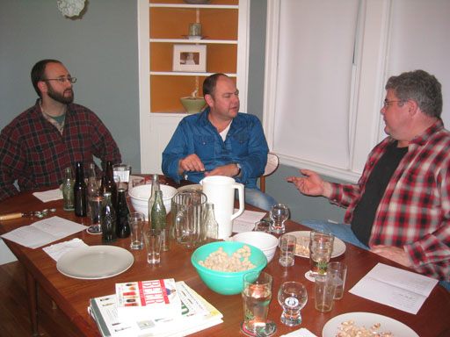

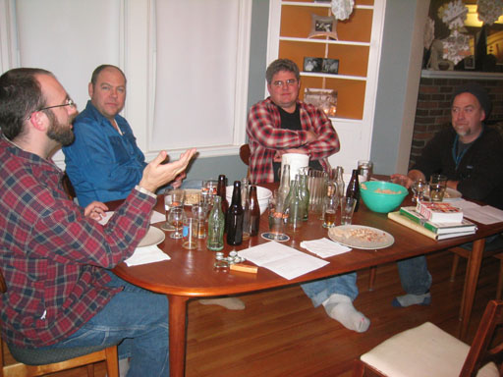

Not all of the caps, but some:
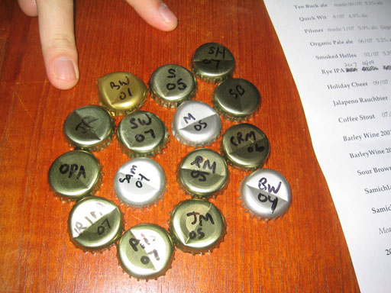
10:40 AM - 3 Comments - 5 Kudos - Add Comment - Edit - Remove

Tuesday, December 11, 2007
Fall Camping trip pics
Better late than never.
We graduated from tent or trailer camping to a full-on equipped cabin, at least for one year. Good weather, great company, awesome food, some poker playing, and of course, just a few great beers. What a fine weekend it was.
Download a zip file with the pics: www.donosborn.com/fall_camping.zip 1.8 MB
See a clip of Jeff's enthralling dramatic readings:
http://youtube.com/watch?v=4x9rMtWGWro

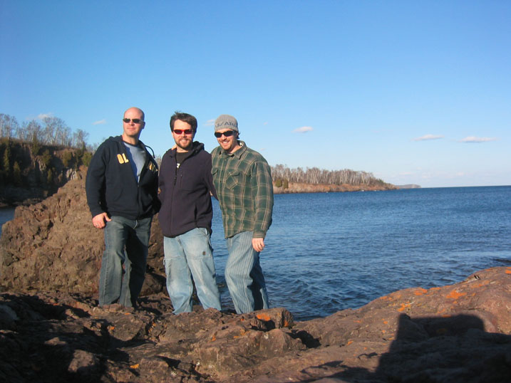

4:39 PM - 3 Comments - 1 Kudos - Add Comment - Edit - Remove

Monday, November 26, 2007
Kiss my Lederhosen, Anheuser Busch!
A couple weeks ago I heard a beer commercial on the radio while listening to a football game. I didn't remember the details but I knew I should be a little irked. Yesterday I heard the same commercial two more times, and now I can confirm that, yes, I should indeed be irked!
The commercial includes a narrator telling us how they would NEVER produce a beer that would fall into three different groups.
1. "We would never serve you a beer made by someone wearing lederhosen." (quotations approximated). OK, so, like, you will never make a crisp Bohemian Pilsner, a malty and strong Doppelbock, a beautifully balanced Munich Helles, or a spring-inducing Maibock? Wow. That's a real shame. Those are all great, and infinitely better than what you are currently producing.
2. "We will never produce a beer like one that your uncle says will put hair on your chest." This one is a little more obscure but I take it to mean a strong or strong tasting beer. So, no Imperial Stout, Dubbel, Double IPA, or strong and wonderful tasting Lambics?
3. "Finally, we will never make a beer that tastes like it was made in somebody's basement!" Hmm. So, you won't produce anything as homemade and wonderfully supreme was an all-grain homebrew? Again, a crying shame.
Because, dear brewery, the beer that you DO feel compelled to make and market to us is none other than Michelob Golden Draft.... Light. I mean.... eh........?
One last thing about the Lederhosen quip. Anheuser Busch owns the Michelob brand. Do they not realize that the brewery was founded by hard working German immigrants? Isn't that a stupid marketing tactic? Often breweries will tap into their German roots, and now Michelob is trying to distance itself from them.
Hey, keep your swill. I have four taps of homebrew that will put hair on my chest, made in my basement, ready to fulfill all my beery needs.

1:02 PM - 1 Comments - 2 Kudos - Add Comment - Edit - Remove

Brewing All Grain Beer - a video tutorial
I made this video from yesterday's brew session. It's just a bunch of clips put together with some dorky narration. Some of you have already seen it but if you have not and you have 6 minutes to kill, here you go.
http://www.youtube.com/watch?v=JMHLqnWCNjE
10:38 AM - 1 Comments - 2 Kudos - Add Comment - Edit - Remove

Friday, October 26, 2007
Bootleg: a movie idea

Do you like interesting historical situations? Do you like beer? Does the Pope poop in the woods? Of course you do, and so do I. I have a handful of books tracing the history of beer in different locations (Germany, Colonial America, more contemporary America, etc). The book I am reading currently: Beer: a History of Brewing in Chicago, has me imaging a cool movie.

The part of the book I'm reading now is about prohibition. always a fascinating topic. It's one of those historical facts that just make me pause and ask, how did that happen? But prohibition in Chicago was an even more colorful time than perhaps in other places. I mean, we're talking bootlegged booze of different kinds, gangsters like Al Capone, "needle" beer that is made weak and then injected with alcohol at the bar, gun fights, big busts by wanna-be heroes, corrupt politicians taking bribes from the brewers to look the other way, and people making beer at home with malt extract made by the struggling breweries.

Wouldn't it be a fun movie that would document this part of Chicago's (and by extension our country's) history? You would have to tell a story though, and that might be a challenge. I think it would be fun to focus on a German immigrant family that risked everything to come to this country and start a new life. With hard work they started a small brewery and had decent success. But prohibition threatens their livelihood and so they must be creative and resourceful. They fight the dry folks and their moralistic ways, but lose. Maybe they make legal products during prohibition. Maybe they struggle with temptation of making illegal beer. Maybe gangsters put some heat on them. The family fights amidst themselves but find they need to stick together to make it. Eventually there is hope and a new start with the repeal of the 18th Amendment.

Could a movie not be made, and could it not be titled Bootleg? You could have scenes of the back room bars. You'd have to show the people making beer at home. You'd have the old folks just wanting a cool beer to drink, not to get drunk and rowdy, but just to enjoy a beer at the end of the day. You'd have cool cars and gangsters and machine guns and middle of the night runs and stake outs and busts and smashed kegs and newspaper photos and more.

Beer is such an integral part of our daily life that it seems preposterous for it to have been illegal. Many people fought the drys before prohibition, and continued to undermine the laws to bring people happiness that the drink affords.

There's got to be a few stories in there somewhere.
 | Currently reading :  Beer: A History of Brewing in Chicago  By Bob Skilnik  Release date: 25 August, 2006
3:32 PM - 3 Comments - 2 Kudos - Add Comment - Edit - Remove

Thursday, October 18, 2007
Pics from 2007 Brew into Books Fundraiser
Good times were had. The party wrapped up around 2:00 am sitting around the fire. One neighbor (to remain nameless, for now) took a snooze on the grass for about 20 minutes. I think it was the mead. He made it home. At least I think. We even managed to raise some $ for books, which I will donate this week.
http://www.donosborn.com/fundraiser/fundraiser5_pics.htm

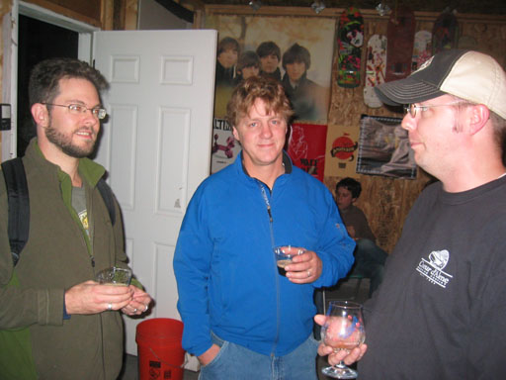

11:22 AM - 3 Comments - 3 Kudos - Add Comment - Edit - Remove

Wednesday, September 26, 2007
Pics of 35W Bridge from 10th Ave
I took these weeks ago, when the 10th Ave bridge was first re-opened. But I have not gotten around to posting them until now.



I found it hard to get the scale of what I was looking at. But sometimes you see a road sign or a worker or a car and then you can get a little idea of how massive this bridge was.

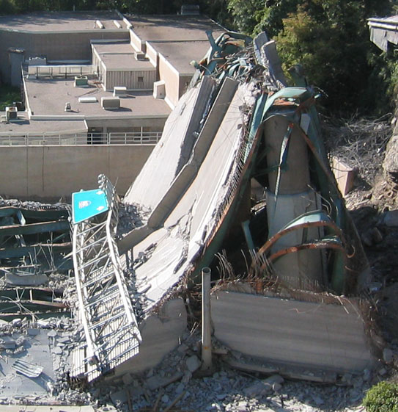


You can see a couple guys to give you some perspective of size.


Getting to work...



It looks like they separate the pieces and then load them onto barges.



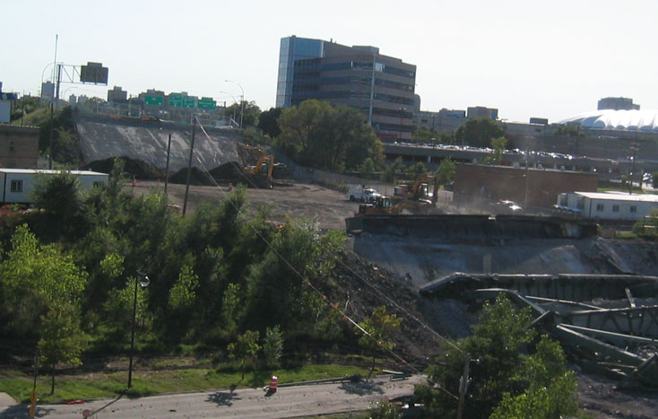
This pictures shows some progress. You can see an area that has been cleared and is ready for the new bridge. It was the only area I saw that was this clear.

12:32 AM - 2 Comments - 3 Kudos - Add Comment - Edit - Remove

Tuesday, September 25, 2007
5th Annual Brew into Books fundraiser
In case you have't heard, we're having our 5th Annual fundraiser. It is always a great time for a good cause.
Check it out and come on by for some good beer.
http://www.donosborn.com/fundraiser/fundraiser5.htm

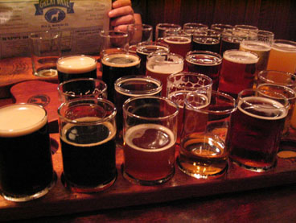
1:15 PM - 2 Comments - 2 Kudos - Add Comment - Edit - Remove

Tuesday, August 28, 2007
Midwest Beer Trip pics and vids are up!
http://www.donosborn.com/beertrip/beertrip.htm
I even took a stab at making a sort of movie about the trip. It's not perfect and not very good quality, but it's fun.
The pics and movie add up to a good summary of what we did.
It was a great time and I'm very thankful for my wife and her letting me indulge msyelf in this manner. :)

3:26 PM - 2 Comments - 2 Kudos - Add Comment - Edit - Remove

Tuesday, August 14, 2007
Cooking up the sauce
What is a guy to do with a plethora of homegrown tomatoes? I've been eating salsa and bruschetta over the last few years until it is coming out my eyeballs. This year I thought I would try something new, something intimidating but potentially worth it.
Italian style pasta sauce!
I read a bunch of recpes on the internet and came up with a general plan of attack.
Here are a few pics.
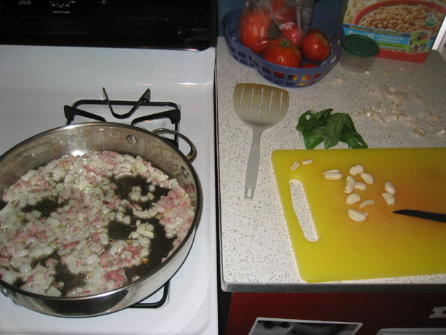
Some of the tomatoes and one of the onions were from Grant. Thanks Grant! The rest of the tomatoes were ours. We used some basil from our garden. First I sauteed onions in olive oil for maybe 10 min. Then I added the garlic for a couple minutes before adding the rest.

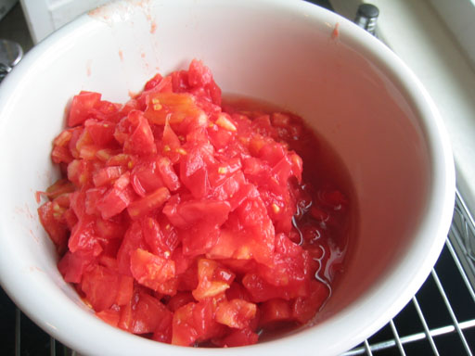
Removing the skins with boiling (and then ice) water, removing some seeds, and cutting them up was kind of time consuming. I had a medium sized bowl mostly full.

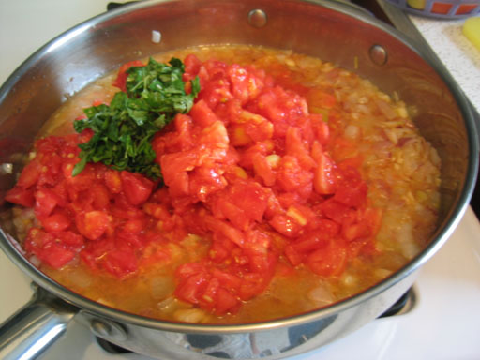
Adding the tomatoes, basil, pepper, and salt to the onions, garlic, and olive oil.

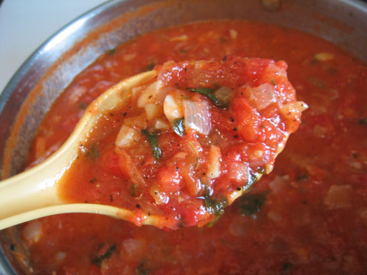
Then I just simmered it for quite a while, reducing it down, concentrating the flavors. After a while the raw tomato flavor gave way to a complex spicy wonderland of beautiful love. It turned out much better than I had hoped, and was probably the best pasta sauce I've ever had. I will definitely make this again, but probably make more at a time.

3:21 PM - 3 Comments - 4 Kudos - Add Comment - Edit - Remove

Thursday, August 09, 2007
Video of me saying Hello at work
A bit of a waste of 30 seconds, but here I am in front of my computer testing out a webcam we have at work. I was also testing out Juno's new "send a video in an email" feature and it seems to work. If I forward the message, then I can see the full URL of the video which is stored for about 3 months. Kinda cool. Basically a quicker (but less permanent) version of You Tube.
to see the vid click here

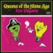 | Currently listening :  Era Vulgaris  By Queens of the Stone Age  Release date: 12 June, 2007

Friday, August 03, 2007
Simpsonize Me
http://simpsonizeme.com/
I tinkered with it a bit but there you have it. I like how they render the scruff.


10:19 AM - 0 Comments - 0 Kudos - Add Comment - Edit - Remove

Thursday, August 02, 2007
Minneapolis Bridge Collpase - pics from my ride in
I took my camera with me today and took some pics. The ones you can see on all the news are much better of course but it is interesting (for me at least) to see the views from the bike ride I take every day.

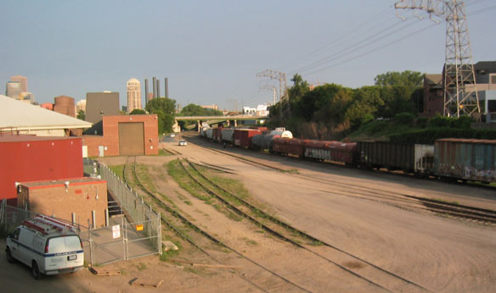

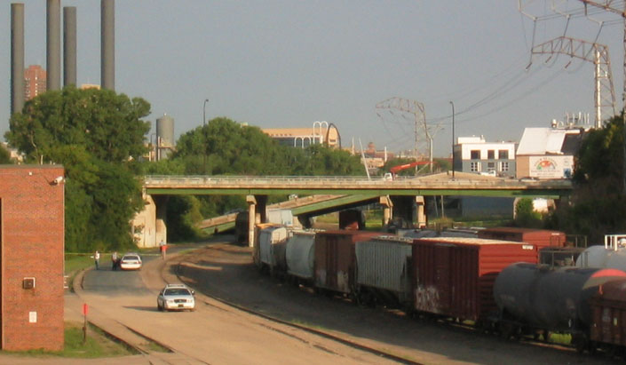
Closeup of above pic.

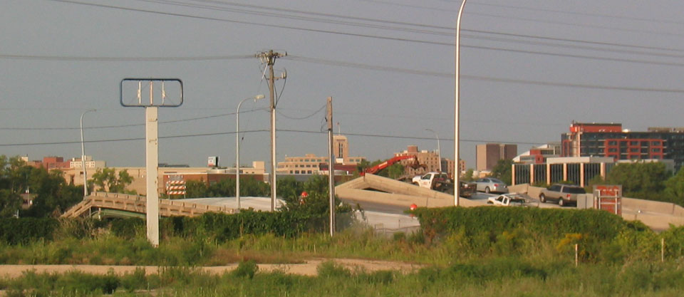
Taken as I get close to 35W. I think I was on University or 4th St.

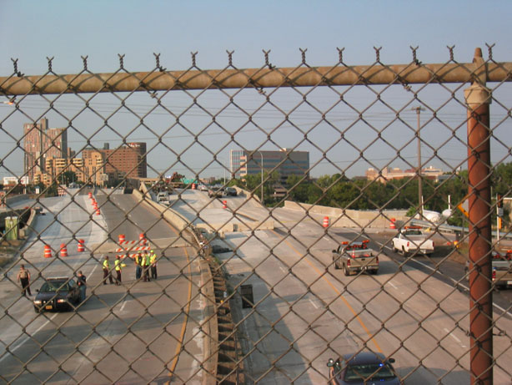
I shouldn't have taken this picture. They had this road blocked off and were funneling cars through little by little. I went around a police baracade and snapped this quick.

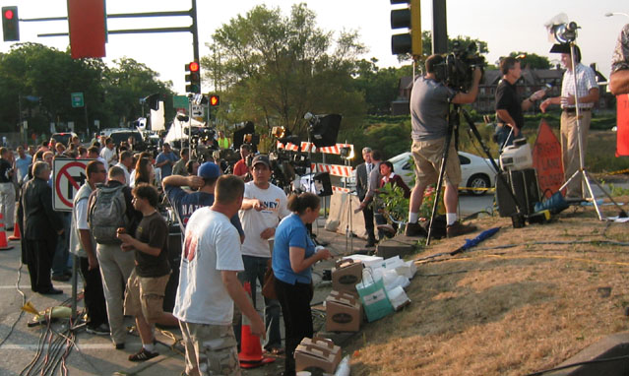
Just after I crossed 35W. You can see the media circus. Tons of cameras and reporters.

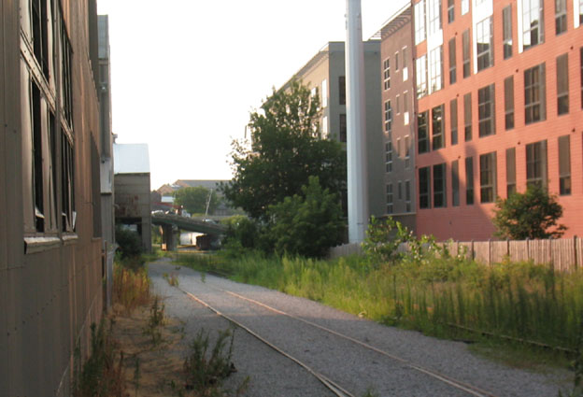
For me this is the most interesting picture and here is why. You can see in the distance the collapsed bridge. Look at the red building on the right. On the other side of it (and parallel to the train tracks you see here) is a road I bike on every day. From looking at the bridge, it looks like the road I ride on had the bridge fall onto it. I have not seen it for sure yet as they had it blocked off. I usually bike through there either around 4:20 or else 5:20. So I would have already been through when it fell. In fact, I biked under it yesterday around 4:20.

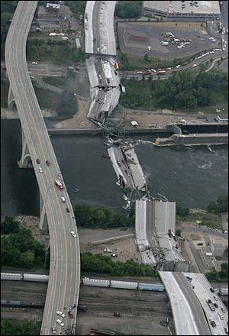
I did not take this pic, but you can see the road near the river that the bridge has collapsed on.


Another pic I did not take showing my road. :(

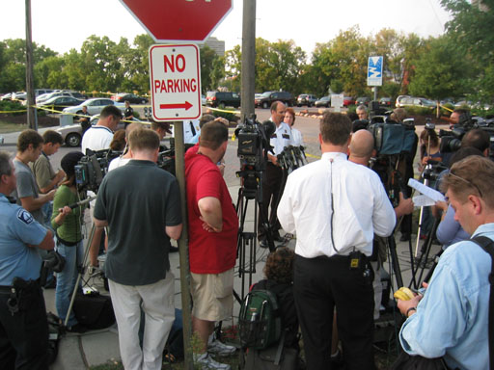
The Stone Arch Bridge was closed. There was a press conference taking place in the park near it.

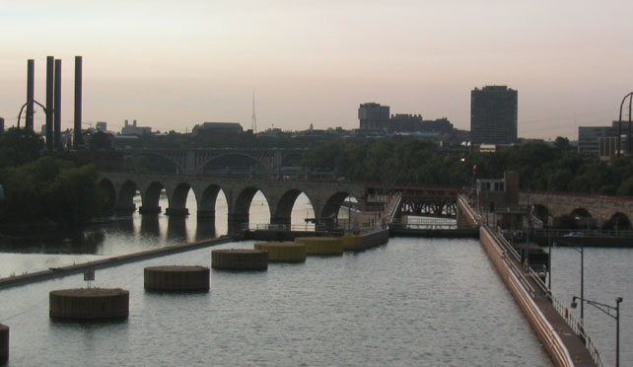
Because the Stone Arch Bridge (seen here) was closed I took the 3rd Ave Bridge. Here is the view looking back towards the bridge over 35W.

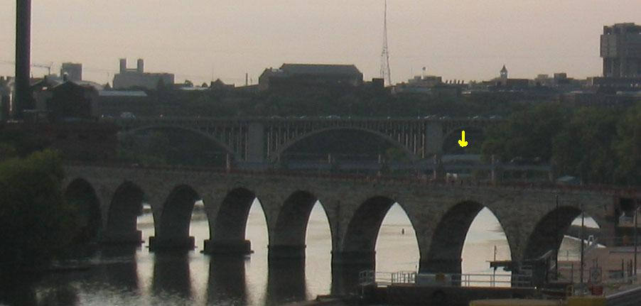
This is a close up of the above pic. I am not sure but I think the yellow arrow is pointing to the collapsed part of the 35W bridge.
Update: one more pic.
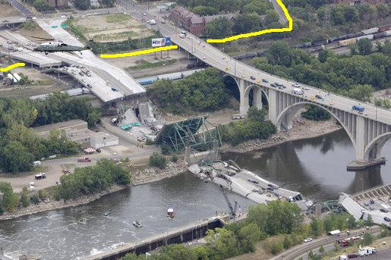
I have discovered that the part of the bridge I bike under did not collapse. You can see my yellow line of where I ride. In the top left you can see that the part of the bridge I bike under was supported sufficiently to keep it from falling down. Of course, it's closed off now and I have to bike around the area.
11:06 AM - 1 Comments - 2 Kudos - Add Comment - Edit - Remove

Tuesday, July 31, 2007
Three Strikes and We are Both Out
Category: Travel and Places
Ah vacation, carefree, relaxing, restful, a time to recuperate from the toils of daily life. Sometimes it works out that way and sometimes not.
My wife often writes about struggles with my dad and their differences on religious beliefs. Well, for completely different reasons, I sometimes have differences of opinion with my father-in-law.
Three things over our last bit of time up North brought me to the point where I just had to pick up Evelyn and walk away. (Took my ball and went home?)
First, I'm a little over protective about my little girl when it comes to her well being, or at least, what I think is best for her (which of course, might not actually be best). So when my FIL has been sitting around all morning, and we finally put her down for a nap, I get irked when he chooses that precise time to go and do some noisy chore, near where she is sleeping, when it could have easily been done earlier in the day.
Second, we are trying our best to not give her much sugary food. In fact, we haven't hardly given her any in her 15 months of life. So when FIL decides to go behind our backs and give her tastes of donuts, and then another time cake, when we have explicitly told him not to do this, it's kind of insulting. Oh sure, it's harmless, I can hear everyone in the world saying that. But it's not about that. It's about respect. She's our child and we want to, for better or worse, take a crack at raising her how we see fit. I had to say "don't give her that cake" as he was reaching out to give her more. "But she likes it." No sh!t she likes it. It's sugar. "DON'T give her that cake" I had to actually say a 2nd time. (a 2nd time? geesh).
The third thing was what pushed me to my limit of patience. They threw a joint party for us (it was our anniversary) and a cousin who was having a birthday. It was supposed to be a short lunchtime thing, but as the Milwaukee's Reserve kept flowing (by the 30 pack), the noisy gathering dragged on. Of course, Evelyn was unable to nap with the commotion, which was a little bothersome. (This was also when the cake feeding was going on). She was so exhausted as it grew closer to her bedtime that she was falling over, bumping into things, crying, and getting into a bad state. I felt so bad for her.
So there I was trying to get some dinner into her, fending of FIL with his cake, when ANOTHER party goer shows up. "It's Dwayne!!!" FIL yells. "All right. Hey Evelyn, say hi to Dwayne!" at which point he literally is picking up the high chair, as I am sitting directly in front of it, trying desperately to feed Evelyn, and wants to turn it 180 degrees just so she can look at Dwayne. This was my last WTF moment. Are you kidding me? "Put the chair down. Do not turn the chair" I had to say, as if talking to a 6 year old. Dwayne can walk around and say hello if he wants to.
Three strikes. You are out. And, I am out, because I am taking my poor baby away from you and all of this noise and mayhem so she can get a little peace of mind. Man did I feel bad for her.
Now I would be completely irresponsible if I did not say that 98% of the time my father in law is great. He is very gentle with Evelyn and loves her so much. He cuddles her and is very patient. He sat with her for a long time one night when she was having trouble going to sleep and they were babysitting. He loves to buy her special toys. When he is down to St. Paul to visit her, he is good about actually being with her. It is just with regards to a few areas that we (including usually Jamie and me together) see things very differently than he does. I wish he would respect our choices about raising her.
After that third strike, I was at the end of my rope too. So, I took my guitar, my homebrew, a lawn chair, and I went down to the edge of the lake. I played "The Needle and the Damage Done," "Let Down," and "You Really Got a Hold on Me" and felt a little better. Later, I was told that one of the cousins saw me down there, withdrawn from the group, by myself, and remarked, not judgmentally but just sort of as an observation, "different." You know what? Hell yes I am different, and I thank God for that.
My wife is different, even though she came from that type of life. And I sure pray that Evelyn will be different too.
Some pics of that weekend:
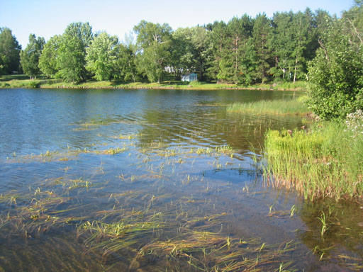

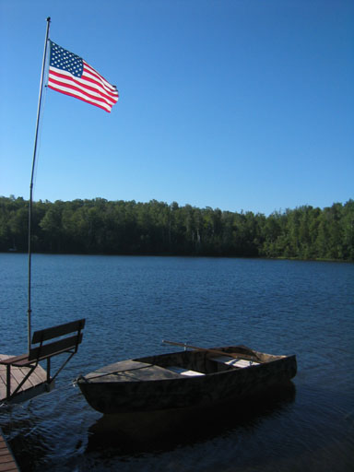

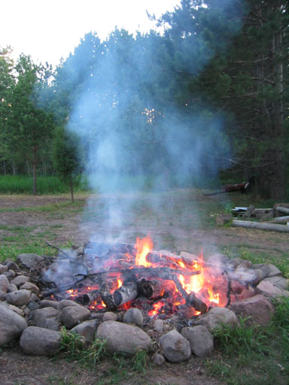

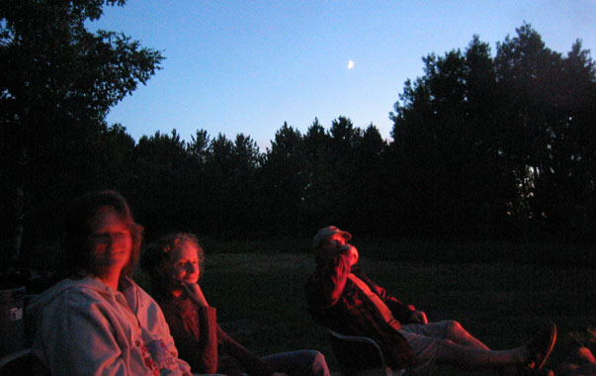
Here is a video tour of the Lake Lot:
http://youtube.com/watch?v=zx2USpaWxps

10:38 AM - 2 Comments - 1 Kudos - Add Comment - Edit - Remove

Thursday, July 05, 2007
"Solid Good Times"
Current mood: Explosive!
Category: Explosive! Web, HTML, Tech
For a second 4th of July I pedaled myself down Summit Ave towards downtown St. Paul to watch the fireworks. I stopped near the Cathedral which is where I was last year.
I defied normal safety practices, and, on a dark 4th of July night with thousands of people around, put a trippy "Experimental/Afro-beat/Pop" record on my Ipod. That is how Studio describe themselves and its a decent start.
You can listen to parts of a few songs here: http://www.myspace.com/sstudio I say "parts" because some of their songs stretch 10+ minutes without becoming laborious or boring. It can be entrancing and mesmerizing, and I thought the songs, saddled with some homebrewed cider in one hand and a hand-rolled smoke in the other ought, to do the night right.
Did they ever. It wasn't a surreal Dark Side of the Rainbow experience like some have had, but it was nice. The record is around 70 minutes long (if interested in hearing it, let me know. It's very hard to find) and the last song was just ending as I was parking my bike back in my garage. A dub-like bass part pulsated to erratic bongos, with clean electric/acoustic guitar strumming, and that would fade into something else altogether. It was pretty fun but the fireworks seemed short this year. I swear it was 15 minutes at most. I was enjoying the explosions (esp the one that looks like a thousand sperm swimming upstream, wriggling back and forth) the beautiful night, the booms, and suddenly it was over.
There was a 30something year old couple snuggling with each other nearby. We were on a steep hill and she was backed up into his legs, kind of thing. She had to keep squirming up hill. He had to re-grab her middle section. They looked uncomfortable and what was even more odd to me was how they kept looking away from the fireworks and towards whatever car headlights were passing by. Were they expecting someone? It didn't look like it. They were probably just too jittery and awkward to sit there for 15 minutes and enjoy the show. Seemed odd to me. Dudes, if you look away for a minute, that's like 1/15th of the fireworks you are missing! That's like 7% or something!
Until next year when another riveting "I biked to some fireworks" report might or mightn't be coming your way.
*************************
Unrelated bonus pic: June raspberries!
We get about this much every other day.
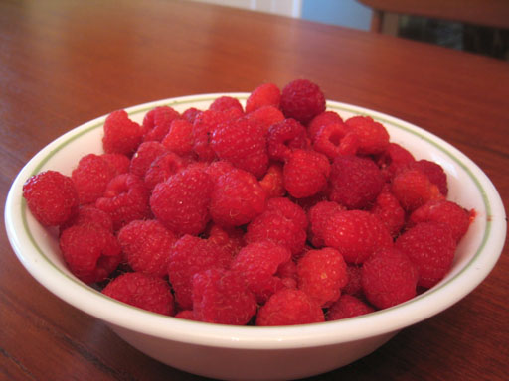
10:43 AM - 3 Comments - 3 Kudos - Add Comment - Edit - Remove

Tuesday, July 03, 2007
Biking to Work in Minneapolis - There's a lot of us
Current mood: content
Ran across this article:
http://www.startribune.com/462/story/1274101.html
It says Mpls has the 2nd highest number of people biking to work in the country behind Portland, OR. I'm thinking..... huh?
I've been to Portland many times and I can understand their #1 spot. It's in a "green" part of the country (the pacific northwest), it is pretty much snow free year round (I've skateboarded there more than once in Jan-Feb), and it is part of this outdoor/active/skiing/snowboarding/mt biking/etc kind of place.
But Minneapolis is #2? Come on USA, that is pathetic. We are buried in snow, ice and cold, making bike riding extremely difficult for at least a few months of the year. Next, we don't have an outstanding public transport situation making driving to work more necessary. [Side note, maybe cities with good bus/train setups don't have more bike commuters because more people use that].
I know we are fairly green in this town, but man, we sure have roads and traffic as well. There is nothing huge to say about this but it just struck me as somewhat odd. We should be proud, sure, but seems to me that a lot of other US cities should be embarrassed. I wonder what the % of people who bike to work is in some other cities of the world, like say Amsterdam or Beijing.
I can say, in the 4 years or so that I have been biking, I have seen an increase in the number of people along the roads and trails.
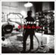 | Currently listening :  Ga Ga Ga Ga Ga (Limited Edition Bonus Disc)  By Spoon  Release date: 10 July, 2007
12:46 AM - 2 Comments - 1 Kudos - Add Comment - Edit - Remove

Thursday, June 14, 2007
Curly Tail Ale on a Night of Outdoor Baseball
Current mood: sweaty
I used to live about 1 mile from Midway Stadium, where the minor league St. Paul Saints play baseball. Over time I learned that after the 6th inning you could just walk in and watch the game without a ticket. Heck, that was 1/3 of the game. Often I would bike down the road and enjoy a summer evening watching the end of a game, sometimes with a Summit EPA in hand.
But then, I moved. Suddenly, I was no longer so close to the stadium. I was now... 2.2 miles away. Har. So as I am sometimes prone to do, tonight I biked down and caught the end of the game. I did last night too, but they were out of the suds that I sought.
We have a new brewery in town by the name of Flat Earth Brewing. Montyhs ago I had their flagship beer, a Belgian Pale, and was unimpressed. But they brew a beer that is only available at Midway Stadium and I think that is a cool thing. I wanted to check it out, so let the adventure begin.

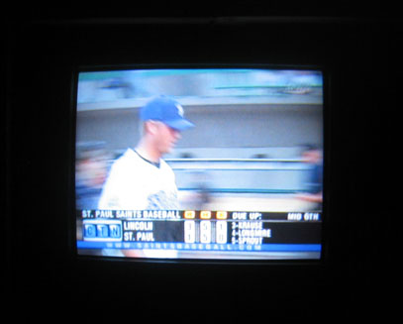
First, I checked the game on TV to see where it was at. Heck, middle of the 6th? Time to go!

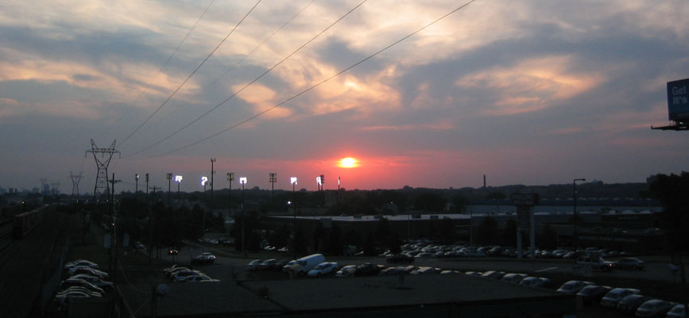
As I bike up the sidewalk of Snelling Ave (west side) here was the view. Looks like a beautiful night for a few innings.

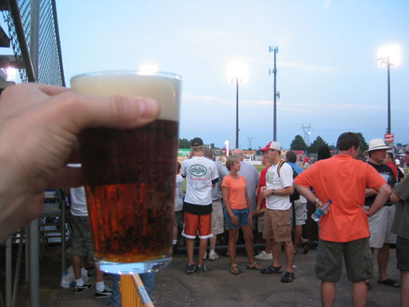
I brought my own glass and poured the plastic cupped beer into it. Cheers.

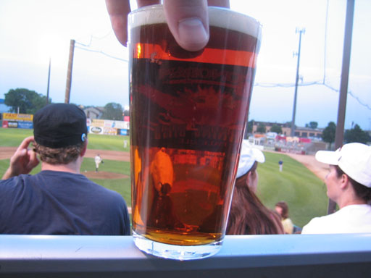
Here you can see how clear it is. It was a nice amber or light brownish red color. Too bad the label of the glass was on the back side of it.

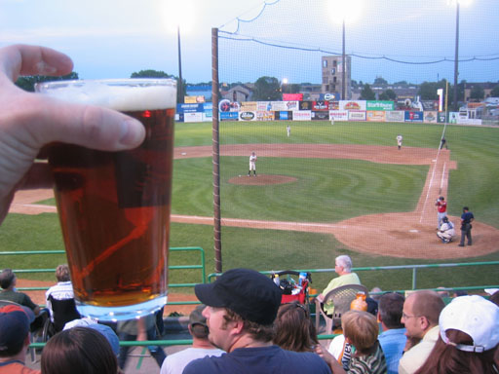
One last shot of the beer from my seat.
Unfortunately, at this rate, Flat Earth Brewing will have the dubious honor of coincidentally, like their name, falling.... flat.
To be generous I was thinking this could be dubbed an "average" brewpub type of beer. Quite dry, no noticeable hop or malt character, pretty thin, no major off flavors but overall a kind of mild grainy astringency that makes it somewhat unpleasant. Then I got more honest with myself and admitted I would have to award it a "below average" rating. And if you are trying to cut out a piece of the competetive craft brew pie, you definitely don't want to be below average.
However, just like last night, I got a coupon for free chips and quacamole at Chipotle as I was leaving. Last night I got a cupon for a free chilito somewhere too, starts with a Z, never heard of it. Tonight I also got $10 off a meal of $30 or more at Buca. My "free" tickets really pay off, huh?
Plus, it's a swell thing to do on an 80 degree summer St. Paul night.
UPDATE:
After I red this review (see below) I might modify my comments. What I described above is basically an English Bitter. I had no idea that that was what he was going for. I mean, a Bitter on tap at a ball park? I didn't occur to me. But knowing that, he basically did hit the style. I still don't think there is enough malt in there but the beer does somehow get a little better knowing this.
----------------
I tasted this one at a beer festival in Stillwater, MN. Is this really a 3.2 beer? This English bitter is true it's "session" self at 3.2 ABV but has a rich mouthfeel that amazed me. It poured copper brown with a tan head and a malty nose up front. It gave away some nice English malty flavor of bread with a hint of grass and a touch of chocolate. Then comes that splash of bitter, but not overly so, from what I assume are some good English hops. It needs to be a touch more sweet in the malt profile for it to really shine, but wow, was this drinkable. The Saints are lucky to have this one on tap.
11:07 AM - 3 Comments - 4 Kudos - Add Comment - Edit - Remove

Monday, June 04, 2007
Year One of Fatherhood - A Small Update
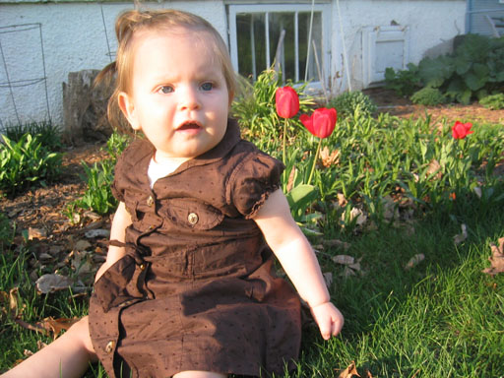
It's been a year of fatherhood and I thought I would write an update to my pre-birth ramblings that appeared here. Some things have happened like I thought they would, but there have also been unanticipated joys.
One thing that was inevitable was less free time. Or maybe I should say less me time? Whatever the term, Jamie and I are pretty independent people. There are some things we like to do together, but for the most part our hobbies don't intertwine. So on any given night we would be doing things independently of each other, without ever a thought that it was a bad thing. I grew quite used to this, but it has changed. I now spend whatever time I can after work with the family, and I enjoy it. And there is much less gallivanting around town to some show, some friend's house, or a bar to check out a new beer. I still get to do that stuff, but less often.
What a year it has been. People say the time goes fast. "You can't believe how fast your kids grow up." Well, when does that start? It was a long year, I felt. So much happened. So many challenges. We get one thing figured out, then there was something else. Then she stops pooping, for up to a week at a time. What? Turns out it's somewhat common. Then the teeth start. It's just one thing after another, often with interrupted and insufficient sleep. It's only been a year?

I'm kidding a little because of course it has been far from a bad year. It has been unbelievable. Evelyn stole my heart from the first time I saw the top of her head (I won't go into details just where that was but...) and continues to do so every time she says "bub-ble," or jams out to the song she triggers on this keyboard but bobbing up and down, or when she almost gets into a cheer-like pattern saying "dad-dy! dad-dy! dad-dy!," or gives her "Mel-mo" (Elmo) a big loving hug, or when she points out the "baby" in a book we're reading, or (this is what really kills me) when she is exhausted at the end of the day and just melts her little body into mine when I pick her up, surrendering her head to my shoulder and just going limp. Like I said, unbelievable. I couldn't have anticipated all of these things. And there is more.

One Saturday morning when Jamie was getting her weekend chance to sleep in, I had Evelyn in her chair in the kitchen. She was eating some breakfast and the sun streamed through the window. Something caught her eye, she pointed to it, and said "bubble." I looked and did not see a bubble, but I did see specks of dust floating in the morning light. I realized, holy cow, she noticed something floating in the air, went through her entire vocabulary, all the words she has at this point to make sense of her human existence, and came up with the closest possible word to describe what she was seeing. Pretty damned impressive I'd say. To get a small glimpse into how the one-year-old human mind works was really interesting, and I'm still playing that scene over in my head.

Her mind is developing, and her love is humbling. What I mean is, she loves her mom first of all, but after that, it's me. She loves me more than anything else in the world, more than hobbies, travel, friends, anything else. She loves seeing me for the first time in a day. The "Daddy!" that greets me makes me realize that this little girl completely entrusts herself to me and her mom. And I think, am I worthy of this? I'm still a f—k up. I get so impatient. I can be so selfish. Sure I'm at least a decent guy, but should she be, for the lack of a better word, worshipping me? It's really humbling and I don't feel adequate sometimes.

So yes, it has been a ton of work. Yes you will not sleep, go out, run around, drink, party, or whoop it up as much as you can before baby. But man, that smile and that hug from your little baby girl, it can replace a lot of nights at a crowded bar.

2:05 AM - 4 Comments - 6 Kudos - Add Comment - Edit - Remove

Wednesday, May 16, 2007
Ten Things You Might Not Know About Me
Category: Quiz/Survey
I was tagged to come up with something along these lines so....

1. Fishing. I used to love it. It was slightly more than a kid's periodic trip to the lake. I bought lures and equipment. I got up early to walk down to the river to catch that elusive bass. My friends and I even rode bike miles into the country, hiked down a path to a river, and caught chubs. We did this so we could use them as bait to try and catch a muskie by the Amery damn. We never did catch a muskie but I spent many a fine summer hour fishing with friends.

2. Kissing. For some reason I got an early start on this. An older girl lured me under a tipped over canoe at the beach and gave me my first kiss. I don't remember how old I was, maybe 7 or so. I liked it. It was mushy and forbidden. Later, I kissed a girl in my parents bathroom. Later still there was more smooching, in the woods. Years later I began to attach emotion to the kissing, but at first it was young boy experimentation.

3. Hockey. I played organized hockey for about 3 years as a kid. I learned the basics of the game but was never terribly good. To this day, though, I still like to skate and play the occasional game of pickup hockey. Also, I become addicted to watching the Stanley Cup Playoffs and finals each spring.

4. Theft. I once accidentally stole $5 from a classmate. I had his wallet, not sure why, and, in front of him as a joke, I took out a $5 bill and put it in my pocket. He didn't seem to care. I fully intended to return it but on my way home from school I realized I still had it. Mmmm, the bismarck I bought at the bakery never tasted so stolen-y sweet and delicious.

5. Rock Star. Ever since high school, I thought I might like to be a rock star. I never seriously thought I could be a professional athlete, but my friends and I were in a band and I thought we were pretty good. Of course, it didn't go anywhere and over the years I have been in a couple other bands. When you're playing a show and people are into it and the band is really in sync with each other in an inexplicable, energetic cosmic way, it's really something. It's a
feeling you want to have again and again. I wouldn't actually want to be a traveling musician, away from home, family, and comfort, but the feeling of rocking the people is really something.

6. Drunkenness. My first drunkenness was not terribly young. I was either 19 or 20, and had no taste for beer or hard liquor. The only thing I could get down was wine coolers. So, an older friend bought a few 4 pks of wine coolers and the game was on. We had a designated driver who brought a couple of my friends and I to a spot in the woods. It was a pretty fun time. I remember thinking for fun I would try to run through the ABC's. I of course screwed them up and we had a laugh. Anyway, my love and appreciation of beer has only developed after I turned 21 and really took form after I was in my late 20's.

7. Paper Route. I had a paper route for 4 years from about grades 7-10. I had to ride my bike a half mile or so just to get to the start of the route. This taught me a work ethic, discipline, and organization. If it was really cold my parents would give me a ride, but most of the WI winter I was biking through ice, snow, and cold. I had to collect money otherwise I would not get my full pay. I count this as a great teenage experience that taught me some good
lessons about life.

8. Penny. When I was under 5 years old I accidentally swallowed a penny. I remember my mom checking my, um, stool samples for days in order to try and find it. I don't know that we ever found it.

9. Teasing. When I was in about 7th and 8th grade I was teased in choir. The popular jocks stood behind me (maybe they were bass singers, I was probably a tenor) and they teased my long hair and hobbies. The thing is, I was on the same baseball and basketball teams as these guys. Well, I think this went a long way towards shaping the person I would become. I knew I couldn't fit in with guys like that, so I sought refuge in being different. I skateboarded, rode freestyle bike, built ramps, bought magazines for these sports (LONG before they were ever on TV or in the Olympics), snowboarded, and started a band. My friends and I were in a band when maybe there was, at most, one other rock band in the whole town. So it was really something different. And I think that spirit has carried with me to this day. So, thanks for teasing me Jeff and Jeff?

10. Taking one for the team. Twice I've been the recipient of violence. Once it was because I was skateboarding as a high schooler. A football player didn't like it and shoved me down.
Another time I was one of about 5 snowboarders at Trollhaugen ski resort. I mean, no one snowboarded in 1989. A skier was hassling me in the lift line, and when we got off he came over to me, shoved me to the ground, then punched me in the face. I suppose this goes with #9 above.

So there you have it.

You got a few things you want to share?
4:18 PM - 3 Comments - 6 Kudos - Add Comment - Edit - Remove

Friday, May 04, 2007
A Matriarch Passes On
Eighty-five year old Charlotte Nelson, or "Nana" as she was known to all her grandkids, passed from this earth Monday April 23. It was not a surprise. She had been on a slow mental and physical decline for a number of years. It wasn't a tragedy and it wasn't unnatural.
She had not been the Nana that we knew and loved for perhaps 3-4 years. In fact, it had been some time since she even knew who her grandchildren were. I think she recognized my Dad, but I would think he would have been one of the last ones to become a stranger to her.
So we aren't really mourning her loss, as she was gradually lost to us over time. What I've been thinking about is all the love she poured into our lives. Letters, presents with hand-drawn illustrations on the white wrapping paper, special treats brought back from her travels, and an ongoing presence at any holiday gathering. She had 9 grandchildren and I'm sure she made all of them feel loved. My wife has even said that Nana was more of a grandmother to her than either of her own.
The weekend of the funeral was the occasion for an Osborn family reunion. Brother Brian flew up from Louisiana and voila the Osborn siblings were reunited. We had two good days of being with each other. The nights were full of goofy singing, empty bottles of wine and beer, campfires in the backyard, even a two-block walk to a local bar to take over the karaoke stage with a blistering version of "Sweet Child of Mine" complete with scatting solos during the 34 bar instrumental. We really enjoy being with each other. Man do we have fun.
(for a limited time you can see some pics and videos from the weekend here: http://www.donosborn.com/podcast/ Look for files uploaded on May 03).
Nana was probably looking down on our family fun and having a good laugh. Even when she was fading, and her mind was less able to coherently carry on conversations, she would say something to me. She would look in my eyes and say, what is really important is life, is family. It's all about family. She wanted us to remember that.
And we have. Now I have my own child, and she has her doting aunts and uncles. She gives us even another excuse to have my siblings over for get togethers and fun. I know my parents love that all their children enjoy each other so much, and I am very thankful as well.
Nana, you were great. We loved you very much. If all goes well, I'll see you in about 50 years. You have that much time to draw a "Welcome to Heaven" present illustration for me.
2:28 AM - 0 Comments - 0 Kudos - Add Comment - Edit - Remove

Wednesday, April 11, 2007
It's Getting Hot in Here, I am Getting, So Hot
Category: Dreams and the Supernatural
There is no longer a debate about whether or not (weather or not? ha) the earth is getting warmer. It is.

The debate is whether or not the warming is man-made or merely part of an unstoppable climate change, an ebb and flow, that occurs over long periods of earth's history.

Years ago I had a difficult time thinking that humans, even us greedy wasteful Westerners, could be doing anything that would actually change the earth's temperature. But over time, the reading I have done convinced me that it was possible that the extra CO2 we emit into the atmosphere, mostly from consumption of fossil fuels, is contributing to the warming.

This is the prevailing "CO2" theory that most people use to demonstrate the need for behavior modification in order to save the planet. I am not trying to discredit this theory; for all I know, it is correct. But it is always useful to read another point of view and so my wife checked out a book from the library for me: Unstoppable Global Warming: Every 1,500 Years.

I am one third through the book and the basic assertion is that there is substantial scientific data to show that our current warming trend is not caused by humans, but is simply a part of a cycle that happens approximately every 1,500 years. They claim there is supporting data for this cycle found in ice core samples from both poles, tree core samples, as well as from sea sediment samples from around the world (i.e it is not just one sample from one location supporting this idea). From what I have read so far, the reason for this 1,500 cycle of warming and cooling seems to be solar flares or sun spots, or at any rate, something to do with the sun. From my non-scientific point of view there seems to be a decent amount of scientific evidence supporting this idea.

What about all the increasing CO2? Surely we are putting a lot of that into the atmosphere? They claim that if you look at temperature rises and the corresponding increase in CO2, the increase follows the temperature rise; it does not cause it. So, there is more CO2 because the temperature is rising. Human CO2 contribution is not causing the temperature to increase.

That is the basic gist. I am not saying I agree or disagree with this idea, but you have to admit, it is interesting. If it is true, then politicians concerned about global warming would not have as much weight behind legislation to modify our behavior. There is a problem with this book though: the writers are condescending.

It is clear that they are interested in maintaining the U.S.'s "right" to drive SUVs, keep the house at 68 degrees in the summer, and guzzle as much fossil fuel as we can. They use terms like "global warming alarmists" when talking about CO2-theory supporters. They whinily defend the notion that we should not at all consider altering our lifestyle to use less fossil fuel.

They also say stupid things like "it would be impossible to replace all of our fossil fuel consumption with alternative energy sources. We would have to cut down all the forests to build wind power and solar panel farms" (my paraphrase). No one is saying we are going to replace all of our fossil fuel consumption in this manner, so to try to discredit such an argument makes them look stupid. Surely moving towards renewable energy only makes sense. Why continue to drain the non-renewable source of oil as fast as possible? Once it's gone, it's gone.

In another segment they use "the Greens" as a pejorative term for people who want to "end or severely restrict the use of fossil fuel." Seriously, is anyone advocating this? I'm sure Al Gore would qualify as a "Green," and from his movie wasn't he encouraging something like a 5% reduction? That would not at all be "ending" or even "severely restricting" our usage.

More arrogance comes out in a statement like "given the urgent desire of the Third World to live as well as American and Europeans" they would be less likely to sign the Kyoto treaty [pledging to use less fossil fuel than their already-low amount]. Mon Dieu! The nerve! To urgently want to live as well as us, to have plentiful food, clean water, housing, and good health? Those greedy bastards. Sign the damn treaty and go back to cooking over dung fires!

There is also a picking and choosing of which scientific claims to cite and which ideas to just let ride. The authors cite any scientific data that supports their primary assertion, but are lax in supporting more controversial statements with citations, probably because they cannot be scientifically supported. An example is "Nothing in the Earth's climate history confirms CO2 as a strong driver of climate warming." Really? Nothing in the hundreds of thousands of years represented in ice core, tree, or ocean sediment samples could possibly be used to support that idea? Huh. Are you sure you looked everywhere?

My point is they are fast and loose with condescension as well as arrogant when asserting the rightness of their own ideas, and they only support them scientifically when it behooves them to do so. It's a shame because an alternative viewpoint in the topic of global warming, and one as potentially significant to the discussion as this, should really be heard.

Despite the attitude, I will read the rest of the book. There are good ideas to be found. I just have to wade through some bull crud. Also, I would be very interested in a "Green, global-warming alarmist's" response to this 1,500 year cycle idea.
 | Currently reading :  Unstoppable Global Warming: Every 1,500 Years  By Dennis T. Avery  Release date: 01 February, 2007

Wednesday, April 04, 2007
A Rogue Start
Category: Travel and Places
Some friends and I have been talking about the merits of Rogue brewing lately. We happened upon a YouTube video showcasing the brewpub and one of my friends mentioned that Rogue was the first brewery that really got him into good beer. Then I was thinking, is there a more consistently solid yet creative brewery in the US? New Belgium is great, but not quite up to that par. Stone Brewing makes awesome beer but is on average less drinkable than a lot of Rogue stuff due to its high IBU's and in-your-face arrogance. Dogfish Heads makes phenomenal stuff but is also not always especially drinkable. Alaskan Brewing makes super solid normal beer, but not many creative boundary twisters. New Glarus is all-around wonderful, but maybe not quite on par with Rogue. Maybe Three Floyds?

As a craft beer drinker in the US, you pretty much have to take your hat off to Rogue. Then I realized, I'll be darned if Rogue was not also accidentally responsible for getting me further into good beer. It was about 1997 and I had been out of college for a couple years and was just starting to seek out better beer. My wife and I were camping at a state park on the Oregon coast. A couple of loud guys pulled up to the camp spot next to us. I thought, great, there goes a night of sleep. I remember making a snide comment to my wife, and later felt bad about it.

They proved to be friendly and also generous. They said they had toured a brewery earlier that day just a few miles up the road in a little town called Newport. The brewery's name was Rouge. Huh, never heard of it. Did I want to try some? They gave me a bottle of Shakespeare Stout. It was unlike anything I'd had. It was a stout, but it also had flavors of chocolate and coffee. It was somewhat roasty and creamy at the same time. I was drinking it on a cool summer night on the Oregon coast with two total strangers. They even sent me on my way in the morning with a few more bottles. They were nice guys, loud, but nice, and I had tasted a wonderful new world of beer.

Later on the trip we were in Fort Collins Colorado to visit an old friend of my wife's. If you know anything about beer and I say Fort Collins you immediately say "New Belgium Brewing." At the time, I had never heard of Fort Collins or New Belgium Brewing. At the local liquor store I did have the presence of mind to ask if there were any local beers to try. The clerk pointed me to an entire cooler of them. I bought some Fat Tire, Brussels Style Black Ale, and a couple of Boulder Brewing beers. Again, what I knew of as beer was even further expanded. An amber ale that was somewhat sweet with a slight Belgian yeast flavor? A malty smooth black ale? They were wonderful.

A few years later I took up homebrewing and as my wife would say, it's been an obsession ever since.

This has been an unsolicited trip into the history of Don's beer growth. No, it's not a tumor.
4:39 PM - 4 Comments - 4 Kudos - Add Comment - Edit - Remove

Friday, March 30, 2007
Living the Dream, or Just Dreaming?
Current mood: thankful
Every now and then I wonder if there is something better.
I know I won't be fixing computers for the rest of my life, but will I always be doing something other than a job more closely related to one of my many passions. There is no real reason to complain about my current situation because as I always tell people, there is a lot about my job to like.
But when I read books like I am now (Brewing Up a Business by the founder of Dogfish Head Brewery), I get jealous. And when I watch Stone Brewing's video blogs documenting the construction of their super cool restaurant connected to the brewery, I am more jealous. Or when there is someone traveling the world and writing about it, or writing about beer, or playing great music to adoring fans, or any number of enviable careers, I am frickin jealous.
An entrepreneur, I am not. I won't put my family at financial risk. I won't be one to take chances to follow a dream. So, I get on the bike, ride to work, and fix computers. Life is good, there is no doubt. I don't take for granted for a minute how wonderful my life is.
But I do wonder, what percentage of people are either doing a job they don't like, or a job they don't mind but one that doesn't tap into any real passion they have. Ninety percent? More? It is hard for me to think of many people I know in that 10%. It does not have to be a high-paying job. More often than not, it might not be. Many teachers really love what they do and can't see themselves doing much else. Someone working for a non-profit could be completely invested in their career.
Then there are the rest of us.
It's not a lament. It's just something I've been wondering.
What about you? Anyone out there in that top 10%? You really are passionate about your work, be it your business or someone else's? Your hobbies and your work collide in a John_Tesh_like new-age symphony of beauty?
Thank God for hobbies. That's what I'm saying.
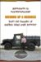 | Currently reading :  Brewing Up a Business: Adventures in Entrepreneurship from the Founder of Dogfish Head Craft Brewery  By Sam Calagione  Release date: 06 October, 2006
2:43 AM - 3 Comments - 3 Kudos - Add Comment - Edit - Remove

Monday, March 26, 2007
Moment of Allignment
Last week I started biking to work again and I fired up the Ipod. One morning I had the new LCD Soundsystem record playing. If you don't know them, they play a hybrid of rock and techno, and mostly want people to dance. It's pretty fun stuff. When one such upbeat song was starting to groove, I heard a cowbell-like sound clinking along with the beat. But looking to my right I saw that it was coming from a brick layer who was banging his scraper on some metal to get something off it. He was making the sound right in time with the song I was listening to for about 4 or 6 beats. I wanted to ask in my best surfer-like jargon, "Dude! Are you, like, listening to the 2nd song on the new LCD Soundsystem too?!" It was a cosmic moment... man...
In less trivial news, CNN sent this headline:
-- The U.N. Security Council unanimously adopts a draft resolution to impose sanctions against Iran over its nuclear program.
Takes me back to 2002 and the lead up to invading Iraq. If you're in Iran, build your bunkers now.
At least it's a U.N. resolution, but we all know if it doesn't "work" in time we will feel free to take whatever action "needs" to be taken.
Question - will Bush try to get some action going before the 2008 election? It's believed that Iran (*cough* whole lotta oil *cough*) is a likely target.
Sadly, it's not even cynical to think this any longer. It's how it is.
 | Currently listening :  Sound of Silver  By LCD Soundsystem  Release date: 20 March, 2007
8:17 AM - 3 Comments - 2 Kudos - Add Comment - Edit - Remove

Friday, March 09, 2007
A Wild Night
Current mood: hungry
For the third time in about a year and a half my company paid for me to ride over to St. Paul from Mpls in a cab, eat and drink all I can in about 1.5 hours at Great Waters Brewing, then watch a MN Wild hockey game. We sat right against the glass one time, in about the 7th row another, and in the 19th row this time. It is one perk of a corporate job. I suppose to paint a fuller picture I should note that, while I am happy with my pay and generally with my job, we don't really get raises any more. I mean, think of 0%, and then think of a number ever so slightly higher than that, and that is about the size of our raise. So these perks are a welcome addition to our "salary."
But this past Tuesday we had another free beer, food and hockey night. A big boss was in town and he went with. He is quite a drinker and party-er. Is this common in executives? We got to Great Waters and I immediately ordered an Imperial Wit. It was just like you'd think. It tasted like a nice Wit but had a little more alcohol. Somehow it worked.
Then the people at the table found a beer they could handle, a Pilsner that was a seasonal beer. We got pitcher after pitcher of that stuff. I probably had 2 or 3 glasses. I finally ordered a Mr. Smooth, which was an English Mild. It was pretty quaffable.
We stumbled over to the arena and got our seats. Mr. Big bought us a plastic bottle of Budweiser so I had that. I was already full to the gills.
The game was great. Having played a little hockey in my day I appreciate the crisp passing and all around unbelievable hand-eye coordination that NHL players demonstrate.
After the game I headed to the street to hail a cab home. I couldn't for the life of me find one and after about 15 minutes of circling the streets, ran into my manager who was also trying to get one. He said the rest of the crew (Mr. Big, Mr. Not Quite as Big, and a couple co workers) ducked into a nearby bar if I wanted to find them. The night was fairly young and I knew there would be a couple free drinks in it for me so I headed that way.
I had a Honkers Ale (Goose Island) and a Red Hook ESB, neither of which I paid for. Both were fine. There was a guy playing songs on an acoustic guitar and people were surprisingly into him. I guess "Pink Houses" never gets old. I used the time to chum it up a bit with Mr. Big and even though it isn't going to "get" me anywhere, it doesn't hurt. If I ever do need a favor, he is a guy who could make things happen. He asked me if I had any requests for the singer and I said "Eagles." He then went up there and soon enough "Take it Easy" had the whole crowd swaying and singing along. It's one of my favorite songs to play on my acoustic guitar.
Then it finally was time to head home. I got in a cab and told the guy where I was going. He said he was facing the wrong way, and didn't start the meter until we made three right turns to be going the right way. I said it didn't matter to me - the ride was on the company anyway. He said he wasn't like those Somali drivers who try to rip you off. He then, to my surprise, busted into a bad Somali accent "hey Mister, I know short cut. I take you quick way. Just go this way with me," implying that they purposefully take long routes home to rack up a high fare.
Then he tells me how this morning a lady asked him to come into his house. He thinks she wanted to f--k him but he didn't do it. Then her son sold him some weed. He said he has been sober from alcohol since the late 80's and he is in AA. But I guess weed is ok. He also said he found a joint in his car one time and figured it was for him. When he was saying this I then realized I could kind of smell a faint weedy aroma in the cab. I thought the point of AA was to take control of your own life and not let drugs run it? I dunno. He gave me a card, Bad Brad's Cab.
I made it home and hit the hay. It was an eventful night, all on the company tab. I like taking advantage of these opportunities when they, like a wisp of smoke from a weed pipe, arise...
 | Currently reading :  Anton Chekov's Short Stories (Norton Critical Edition)  By Anton Pavlovich Chekhov  Release date: April, 1979
12:40 PM - 5 Comments - 4 Kudos - Add Comment - Edit - Remove

Friday, February 23, 2007
Scaring the Hell out of Me
Category: Religion and Philosophy
You will take the mark, or die!


As a Christian lad in a conservative home, I spent many a Sunday night at church. Once in a while we would watch a film. These events produced some horrifying memories -- watching apocalyptic, mark-of-the-best, Christians-on-the-run, guillotine-swinging bloody action!

If you were from a similar background, maybe you saw some of these too. After doing a little research I am pretty sure that the main film I remember is "Distant Thunder." I think I also saw either "A Thief in the Night" or "Image of the Beast." (I read about the people behind these films as well as the films themselves here: http://www.jesus21.com/content/movies/rapture1.html More on the films on page 2. It's some cheeky writing and I sympathize with a lot of what he has to say).

The more I think about it, the more wrong these movies become. I mean… where to start? I'm not going to go after the film as bad art. It's too easy and unnecessary. I'm not even going to go after the motivation to make such a movie. What I really want to know is, in what God-forsaken, f—ked up culture is it considered to be a good idea to show these movies to a 10 year old? I might have been older than that, but not much. And my younger brother certainly wasn't.

To extend the discussion larger than these rapture movies, I've been thinking about what motivates different people in the church. A lot of what motivated the people in my church growing up was fear. This is a common facet of fundamentalist church goers, but I didn't notice it at the time. It was my life and I knew nothing else. Of course I didn't want to go to hell, or be left behind after the rapture and have to stand in front of evil Christian haters ready to persecute me for my beliefs. It was frightful.

My wife has recently discovered a couple books that have her all warm and happy on the inside. One of them is "If God is Love" by Philip Glley and James Mulholland. They raise the question, should your beliefs unite you with others, or divide? Are there boundaries to God's love, and would he be able to eternally exclude some of his creation from himself? Why do we kill each other incessantly if God is love?

I've just started reading this book but it has been interesting to contrast it with the ideas I grew up with. If my faith wasn't sincere I might end up forever suffering in hell. If it was sincere (but I somehow missed the rapture) I might have to face the guillotine, assuming I had heart enough to remain true. Plus, I shouldn't swear, drink, lie, cheat, steal, or have lustful thoughts. It was a heavy trip.

I was on the phone with my Mom recently and I ran these movies by her. I love my parents, and they believe what they believe. I don't think they will change much. I think she still essentially agrees with the theology in these movies, but she did concede that maybe it wasn't best to show them to young children. I'm sure my parents didn't even quite know what to expect. She also admitted that back then being a believe was very new to them, and they were just trying to figure it out. A Sunday night movie at church? Bring the whole family!

One could go on and on about this. Perhaps there is more to talk about another day. But that's what's been rolling around the noggin lately.

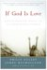 | Currently reading :  If God Is Love: Rediscovering Grace in an Ungracious World  By Philip Gulley  Release date: 11 October, 2005
3:06 PM - 4 Comments - 6 Kudos - Add Comment - Edit - Remove

Tuesday, February 06, 2007
Relax, Don't Worry, Have a Homebrew (or dozen)
For my Superbowl "party" (a beer-nerd friend and I sitting, eating, drinking beer) we decided to go exclusively homebrew. Usually we will drink about 50/50 commerical and homebrewed beer. But to celebrate our brewing over the years we decided to dust off some vintage bottles and have some fun.
Here is what we had:
-Pilsner Urquell clone - Don's
-Helles - Don's, light German lager.
- RyeIPA -Don's
- Sizzle Chest Coffee Stout - Mike's
- Apple Ale - Mike's
- Baltic Porter -Mike's
- Rye Bock - Don's experimental lager
- Barleywine - Paul's (Mike had in his fridge)
- IPAx2 - Mike's
- Samichlaus 2005 - Don and Mike's. 15.7% alc.
- Old Ale - Mike's
- Imperial Stout 2002 - Don's
- Golden Ale - Mike's, Belgian
- Maibock - Don's
What a great variety. We didn't even get to my Barleywine 2004, Sour Brown 2005, or any meads. We didn't get to Mike's Barleywine either.
It was a pretty satisfying experience. We have both been brewing for a number of years, and have built up quite a stockpile of beers that can age. My 2002 Imperial Stout has held up very well. Mike's IPAx2 must be 3 years old at least, and it has mellowed nicely but still retains a strong hop flavor.
Fire up that kettle and get brewing!

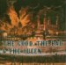 | Currently listening :  The Good, the Bad & the Queen  By The Good the Bad & The Queen  Release date: 23 January, 2007
10:03 AM - 0 Comments - 0 Kudos - Add Comment - Edit - Remove

Saturday, February 03, 2007
Surly Brewing aces beer snob exam
If you asked any beer snob where the home of snobbery is, he'd most likely reply www.beeradvocate.com . The website has been around for some time and has thousands of reviews of just about any beer in the world. The two site founders recently started a print magazine and they include some reviews in each issue. The first official issue feature not one, not two, but THREE reviews of our very own Surly Brewing. Holy schnikeys did they get glowing remarks.
If you look at the grades, you'd think that they hand out A's like beer samples at the Great American Beer Fest. Not so. They recently handed out a D+ to a bottle of aged Sierra Nevada Bigfoot Barleywine they felt did not measure up. They are often pretty tough on beers, and it is quite an accomplishment for Surly to be reviewed so highly.
I am almost certain that these reviews will further increase national interest, at least in the beer snob world, in our little-brewery-that-could.
Congrats once again to Surly.
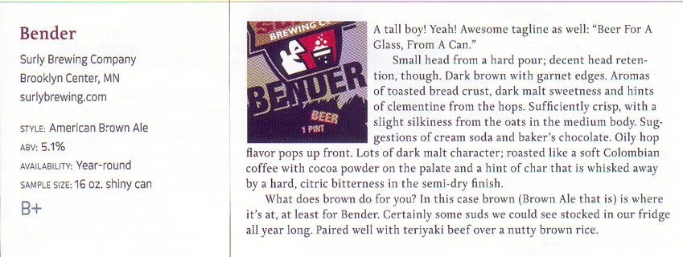

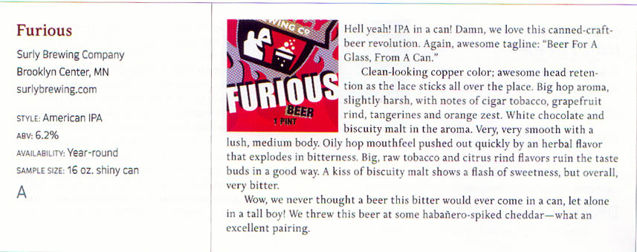

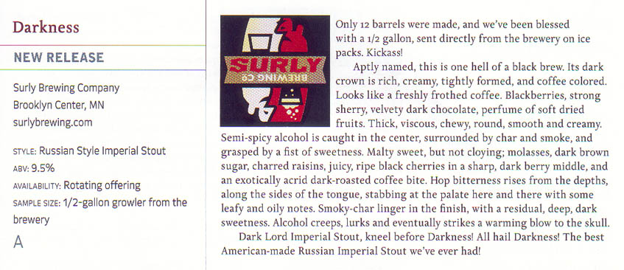

for more user reviews: http://beeradvocate.com/beer/profile/13014

11:42 AM - 2 Comments - 2 Kudos - Add Comment - Edit - Remove

Tuesday, January 30, 2007
Sgt Pepper for the Baby
Current mood: chipper
I looked at Evelyn last night and I thought, yeah, she's old enough. So I got out my vinyl record of Sergeant Pepper's Lonely Hearts Club band. Jamie had commented recently that Evelyn seems to be more aware of music and even gets a little excited when she hears something she likes. SPLHCB is such an amazing record, because even a 9 month old can bop along to the opening title track, or "With a Little Help from My Friends," "When I'm Sixty Four," "Getting Better," "Lucy in the Sky with Diamonds" and many other songs. But then there are songs that you can spend a lifetime trying to figure out and fully appreciate, namely "A Day in the Life." It really is an amazing work. And she seemed to like it. She was tapping her hands, her feat, even getting up on all fours and kind of moving back and forth. What a cutie.

I can't remember the first time I heard that record. I think I was probably in my 20's. :( Way too late. So Evelyn is getting a head start. It was kind of fun to be there with her the first time she heard this monumental work. I mean, maybe I'm a sap but it was kind of a significant moment for me. Music is an important part of my life and to begin to be able to share that with Evelyn is pretty cool. Hopefully through the years I will introduce her to dozens of wonderful albums. She already seems to like the dense sound of Wilco records.

Is she ready for Pet Sounds? ;)

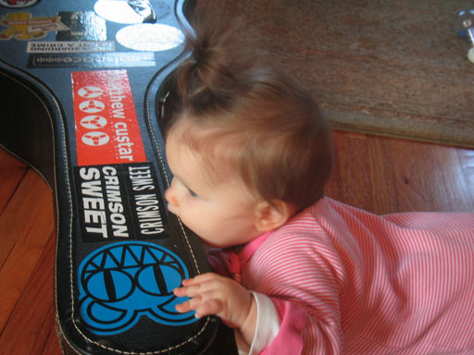

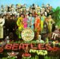 | Currently listening :  Sgt. Pepper's Lonely Hearts Club Band  By The Beatles  Release date: 11 July, 2002
11:32 AM - 4 Comments - 2 Kudos - Add Comment - Edit - Remove

Monday, January 29, 2007
Sam Adams Longshot Contest - The Beers are In
Have you heard of this contest, do you know of this thing? (Sounds like a stand up routine). Homebrewers sent in samples of their homebrews and tried to be the lucky winner whose batch would be brewed and sold by Boston Brewing Company (maker of Sam Adams). Originally I thought only one person would win, but it turns out that three did.
I want to saw how impressed I am that a large brewery would do this. First of all, it greatly increases the exposure that our hobby receives. While perhaps most people who buy Sam Adams know that you can homebrew, people watching TV and catching a commerical about it might not have.
Also, it shows how Boston Brewing is committed to staying true to its roots. Jim Kock was a homebrewer, I believe, and it's nice to see that.
Thirdly, BBC is not afraid to take risks. They put out their winter sampler pack each year with a Cranberry Lambic. Granted, it is not a very good lambic, but when is the last time Budweiser released one of those? They also make their Tripple Bock and Utopias, very strong, original, and expensive beers.
Lastly, it gives homebrewers a chance to shine. People all around the country are drinking a beer that a homebrewer dreamed up. And you know what? The results are good, very good.
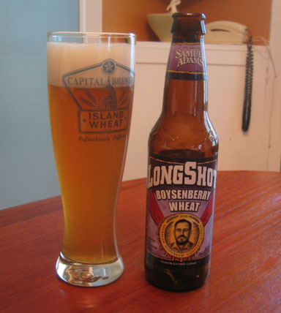
First up is Boysenberry Wheat. It was not overly sweet (I'm looking at YOU, Leine's Sunset Wheat) but it had a hint of beery goodness. It was not overly "wheaty," either, which made it (for the masses) a little more drinkable. My least favorite of the 3, but still a solid beer.
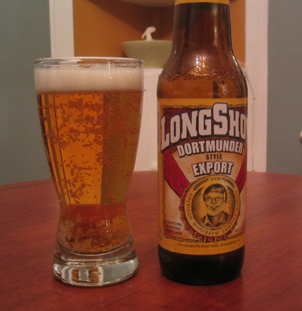
Hot damn, now that is what I'm talking about. This golden lager was brilliantly clear. The flavor was perfectly balanced, mostly malt with just enough hop bitterness. This is a tough style to do, and it is done well in this example.
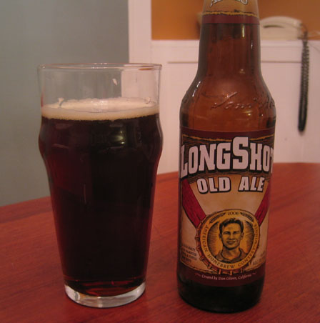
This was the surprise of the 3. It is over 10% alc, which means it is much more expensive to produce. While it is properly brewed and tastes like an old ale, it must be extremely young. The winners of this contest were just announced in Sept. I don't know when this was brewed, but it can easily age for a year to mellow out. It can most likely be aged for 5 or even more years. I will save my last bottle for a while, and might even buy another 6 pk for the delicious Export and more Old Ale to sock away.
So congratulations to Boston Brewing Company for being infinitely better than a lot of its larger-brewery counterparts.
cheers.
 | Currently reading :  Fermenting Revolution: How to Drink Beer and Save the World  By Christopher Mark O'Brien  Release date: 01 November, 2006
12:59 PM - 4 Comments - 5 Kudos - Add Comment - Edit - Remove

Wednesday, January 24, 2007
Congratulations Surly Brewing, one year old
Current mood: grateful
Winterfest 2007 just took place, and it was at Winterfest 2006 that Surly debuted to the public. I believe they had both Bender and Furious (but I don't think they had names for both yet). Heck, let me consult my notes. Ah yes:
- Surly Brewing (inaugural tapping!) - Bender - assertive. nice.
- Surly Brewing - unlisted. Amber IPA thing, on cask. Super hop aroma. Taste is strong. [I am guessing this was Furious]
Last night Grant and I had the beer they brewed in celebration of their one year anniversary, appropriately called "One."
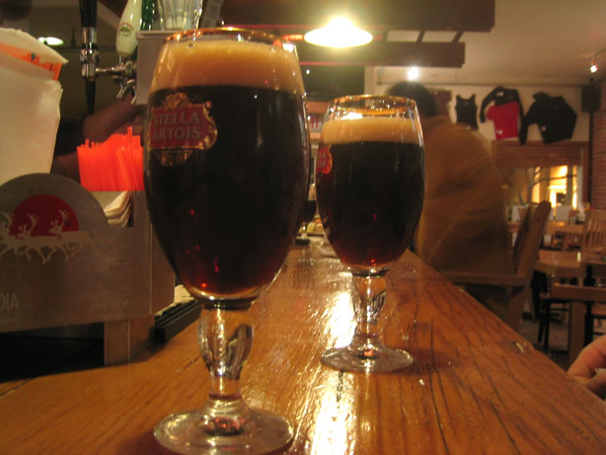
From their website: This year's beer is a strong lager. Aged about 6 months and weighing in around 9% ABV.
If I would have been taking notes last night I would have written: no strong aroma, if anything, some malt. Flavor is tipped to the sweet side. Brings to mind brown sugar and maple syrup. Probably a lot of residual sugars (would make sense for a high gravity lager). Very smooth, though (also makes sense for a lager). Seems like I detect a Belgian yeast flavor, but that doesn't make sense if it is a lager. Something kind of musty or tart is a mild counterpart to the almost-over-the-top sweetness. Extremely drinkable for 9% alc. It isn't until the beer warms that I could even get a hint of the alcohol.
One thing I liked about "One" was that it was not like the other Surly beers. It was different and somewhat adventurous, but it was much sweeter than anything else they've made. It proves they want to brew whatever they want, and they'll do a good job of it.
Here's to another year. And then twenty five more.

 | Currently reading :  A Passage to India (Penguin Classics)  By E.M. Forster  Release date: 28 July, 2005

Thursday, January 18, 2007
Utah snowboarding trip January 2007 pics and vids
Most of you already know about this, but in case not.....
http://www.donosborn.com/Utah2007/utah2007_1.htm
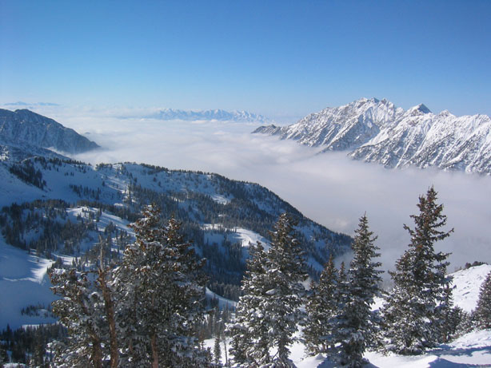
3:30 PM - 4 Comments - 4 Kudos - Add Comment - Edit - Remove

Friday, January 12, 2007
Life Without Beer...
is no life at all.
After the holidays, the belt gets tighter. In the winter when I am not biking, the waistline expands. Recently I decided, all right, I was up to a weight that I don't like to get much above, and something had to be done.
So, I cut out beer for a few days and hit the treadmill.
Because I keep on top of my health pretty well, it didn't take long to get back down to a decent weight. But man, those days without beer sure were missing something. It's such a regular part of my life, that glass or two of finely crafted homebrew or other commercial beer. It's something I look forward to each day. It's relaxing. It's a nice predictable part of enjoyment. It's my quality of life.
But, it can lead to extra poundage, especially when I am not exercising as regularly as I do for most of the year. Of course, it's a stereotype that beer drinkers are fatties. And, sometimes it's true. One of the most well known beer writers is Lew Bryson, and he was a pretty big fella. I noticed recently that he decided to do something about it, and it was interesting reading. Hats off to him.
http://www.alestreetnews.com/articles/15_4_12.htm
Who knows? Maybe it's a trend. With the appreciation of craft beer seems to often come a more mindful, life-embracing way of life. Mountain bikers like to drink a nice glass of beer after a day of riding. So do snowboarders, mountain climbers, hikers, whatever.
People seem to be realizing that along with an appreciation of fine beer is a respect of their health. I dunno; that's how I feel anyway.
And on that note, I'm off to Salt Lake City, Utah tonight for a few days of snowboarding in the mountains. It will be my 7th consecutive mountain trip, and I look forward to it all year long. Much thanks to my wife for holding down the fort and watching over our baby while I am gone.
At the end of a hard day of snowboarding I hope to enjoy a Squatters or maybe a Uinta ale, local Salt Lake City beers. Even though the state is mostly Mormon, there is good beer to be had. I think it comes with that mountain lifestyle I was mentioning.
Surf's up.

12:42 PM - 5 Comments - 6 Kudos - Add Comment - Edit - Remove

Tuesday, January 09, 2007
The Curtain has Been Pulled Back
Current mood: tired
Do you ever get that feeling that you've been played for a fool? I remember sitting in a bar in Chicago on St. Patrick's Day 2003, listening to Bush give Saddam his final chance to get out of Iraq. I thought, well, we've given them ample warning. We've tried to inspect. We've sanctioned. Saddam is a bad guy (which indeed he was) and so we're going in.
Years later when so many of the Bush administration's lies and fabrications have come to light, I feel, well, kind of tired. I'm tired of the greed and deception. The funny thing is, after 8 years of deception and trickery by Clinton I was ready for a down-home, honest, straight-shooting guy to lead our country. I thought we got that, but obviously I was wrong.
Antonia Juhasz wrote "Spoils of War" in the current In These Times magazine. Let me document a few items that continue to pull back the curtain of our bumbling leader, fast ruining any possibly-good U.S. reputation the Middle East.
1. American companies like monopolies…. when they run them. The rebuilding contracts in Iraq "even though Iraqi companies had successfully rebuilt the country after the previous U.S. invasion," have overwhelmingly been assigned to U.S. companies. [any quotes are from the above listed article] More than 150 U.S. companies were awarded contracts for post war work totaling more than $50 billion.
Not only have many of these contract not been completed (or even started), been poorly managed, and even had some of the companies take the money they've already been paid and head home, but there are thousands of Iraqis who are unemployed. Estimated unemployment rates are 30-50% in Iraq with it as high as 70% in some parts (probably the most dangerous areas, I suppose). Surely there are many eager Iraqis willing to work hard to rebuild their country, and probably for much lower wages (and... possibly much more fervently and thoroughly) than the U.S. companies who have the contracts. Sad.
2. We went to war for a "freer and stronger" Iraq. These are my terms but they sum up part of the argument for going in. Get rid of the evil Saddam. Bring freedom to Iraqis. Remember the "Liberate Iraq" signs? However, when the curtain is pulled back, we see the real reason we went in. "Planning to secure Iraq's oil for U.S. companies began on the tenth day of the Bush presidency when Vice President Dick Cheney established the National Energy Development Group..." At least there was something they were ready to get to work on. By March of 2001 lists of oil companies who had contracts with Iraq had been produced. It's kind of like international oil networking. Bush and company were just itching for a way into Iraq's rich oil reserves. How fortunate, in that regard, for the New Pearl Harbor (9/11), which, in their opinion, gave them reason to (eventually) invade Iraq. It's too bad they had to waste time with a pesky stop in Afghanistan first. We all have seen how ultimately devoted they were to truly tracking down Osama.
After the Iraq invasion, oil is still a huge target. Ayad Allawi, part of the Iraqi puppet government, submitted guidelines that turned all "undeveloped oil and gas fields over to private international companies." Allawi's proposal would put 64% of Iraq's oil into the hands of foreign firms, and if a further 100 billion barrels are discovered, which is widely predicted, that amount climbs as high as 81%. Can you possibly imagine if 81% of some American valuable natural resource was controlled by foreign companies?
So much for a freer, stronger, independent Iraq.
3. First we take Baghdad, then we take the world. The Bush agenda "has never been limited to Iraq." From some of my other readings, this is true. And it isn't just Bush, but it's been U.S. foreign policy for years. We've been meddling about just abut everywhere. A Wall Street Journal article put it this way: "for many conservatives, Iraq is now the test case for whether the U.S. can engender American -style free-market capitalism within the Arab world." Makes me wonder, who is next? Algeria, Egypt, Jordan, Israel, Libya, Saudi Arabia, or perhaps even.... Iran? I mean, I know it's a stretch, but can you imagine our government coming up with a reason to, say, invade Iran, replace the existing government, and install leaders friendly to U.S. trade? Naw. I must be smoking something.
With great privilege comes great responsibility. Let's get on that responsibility thing.

1:10 PM - 3 Comments - 4 Kudos - Add Comment - Edit - Remove

Thursday, December 21, 2006
Two Thousand Five Hundred Five
That's how many miles I biked this year. I don't think I will bike any more but I guess we will see.
For my last bike ride of the year, I took my camera. Here are a few shots.

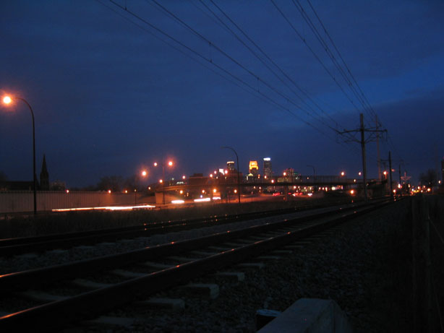
I wrote the other day about Interpol's "NYC" playing on my Ipod when I rounded a corner and got my first view of the downtown skyline. This is approximately that view, although on that day the sun was up a little more and was shining on the East-facing glass walls of the buildings.

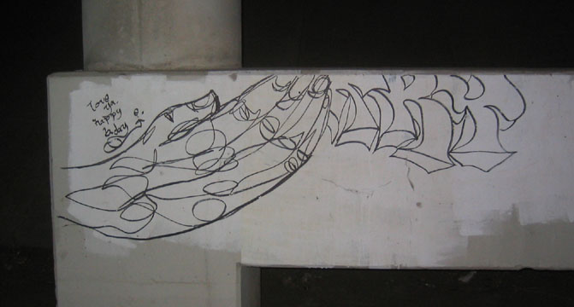
If I take one way into downtown I pass this grafitti under a bridge. The first couple times it just looked like scribbling, but then I saw the hand. It always catches my eye.

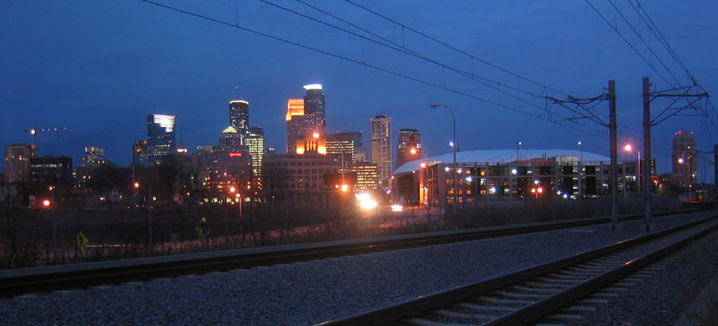
As I am getting very close this is the view I have right before I cross 35W.
That will probably do it for this biking season. I got my most miles ever. Tonight I am drinking a bunch of beer with some good friends and watching the Packers (hopefully) beat the Vikings for the 2nd time this year.

11:12 AM - 3 Comments - 1 Kudos - Add Comment - Edit - Remove

Tuesday, December 19, 2006
I'll be in Belgium for Christmas, if only in my dreams
Category: Travel and Places
Do you dream in color? I know I do, and quite often I remember what I dreamt about. Last night was a real life dream turned into an unconscious one.
One day I would love to take a couple of my biggest beer drinking nerd buddies and go to some of the wonderful beer places. A few must sees would be Amsterdam (wonderful beer bars), somewhere in Belgium (land of the most unique beer on earth), and Munich, Germany (heavenly biergartens under the stars with liters of wonderful Helles). Another place I have not been to but I will (darn it!) one day is Bamberg, Germany, home of the infamous smoked beers.
Last night in my dream Mike, Jerry and I were in Belgium somewhere. Although I have only been to Bruges, we were in Brussels last night. We had tall glasses of Trippel, I remember. They were Tulip glasses which probably isn't how it would actually be served. We were in ecstasy.
Then we left one bar and started walking around. It was kind of a rural small town environment which doesn't make much sense. But we found another bar and were astounded at the variety and scope of the bottle and draft selections. Then of course I woke up.
Side Note about this morning:
I've been still riding bike to work even though it has been 17 degrees or so in the morning. Today it was dark when I was riding in. When I got part way the Killers record ended and Interpol "Turn on the Bright Lights" started. Man oh man. Those first haunting notes of that opening track starting ringing all reverbed out in my head, I was cruising down dark paths with empty trees all around, it was spooky. "Surprise, surprise.... I'll come around...."
When I got closer and was just turning to see the downtown Minneapolis skyline the song "NYC" came on. "You have supported me for a long time. Somehow I'm not impressed...." And right when the chorus "New York cares..." hit the sun was rising and shining off all the glass of downtown. It was perfect. It was a great ride in.
And if I can do it one more day I will achieve my highest miles ever in a season, over 2500.
out!
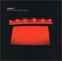 | Currently listening :  Turn On the Bright Lights  By Interpol  Release date: 08 October, 2002
11:58 AM - 4 Comments - 6 Kudos - Add Comment - Edit - Remove

Wednesday, December 06, 2006
Frivilous Fun - my celebrity lookalikes
My friend Jonnie had this in his Myspace. I thought I'd give it a shot. Can't say I'm unimpressed with my matches. I killed on this thing!
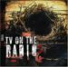 | Currently listening :  Return to Cookie Mountain (with Bonus Tracks)  By TV on the Radio  Release date: 12 September, 2006
12:31 PM - 4 Comments - 3 Kudos - Add Comment - Edit - Remove

Friday, December 01, 2006
I have seen the Devil, and he shops at Wal Mart
I recently watched a documentary Wal-Mart: The High Cost of Low Price. Maybe it's too easy to take shots at Wal Mart, a bazillion dollar behemoth company. Maybe I was more uninformed than an average person, but after learning some things from this film, I don't think I can ever shop there again.
http://imdb.com/title/tt0473107/
I don't want to be that guy who falls over backwards after every new documentary he watches or book he reads. I don't think that I am a total sucker. Let's just say that if you ever shop at Wal Mart, consider checking this documentary out and see what you think.
A few of the more troubling points in the film are:
1. Wal Mart pays their employees much less than they could or should. Not only is the pay low, the benefits are crap. No one goes to Wal Mart looking to make a million dollars, but the way management viciously keeps unions out keeps wages low and profits high. A strange irony is that by paying their workers little, they make double profits. They keep the money that they don't pay their workers, and their workers, looking for the cheapest buys around, funnel a lot of their paycheck... right back into Wal Marts cash registers.
2. Wal Mart execs make no bones about going into small towns and running long-time businesses out of town. Many downtown areas, once thriving places of local business, are now ghost towns. A small clothing or hardware store can simply not compete. Wal Mart executives sometimes jokingly drive around a new town where a Wal Mart is going up, and point at local business while they laugh, "there's one that will be gone in a few months, there's another, ha ha ha." There was one anecdote of this from a former manager.
3. Because Wal Mart is a boon to the local tax dollars, city and county governments give them major subsidies and other breaks. A local hardware store owner says he never saw one cent of help from these groups, whereas the local Wal Mart was getting however many thousands of dollars.
4. The film shows where some of the goods are made. Poor Chinese workers labor long, long hours for very little pay. They often live in squalor in so called "dorms" where other workers live. They have no union voice or protection and make basically no money. They do not make enough money to live in a normal apartment and don't have much choice but to live in the company lodging. They work such long hours they don't have much time for anything else. I suppose one could argue they are working there by choice, but their sh!tty lives is why you can buy Wal Mart products so cheaply.
These are just a few points off the top of my head. It is not a case of "Capitalism is so evil." I'm not against companies making profits. I'm not even against some companies making LOTS of money. But you have to consider at what cost are these profits being generated? Espcially when you have a company like Wal Mart that espouses family values and claims to be SO pro-family, when you look at the truth, you learn of the intolerable hypocrisy.
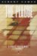 | Currently reading :  The Plague  By Albert Camus  Release date: 07 May, 1991
4:13 PM - 25 Comments - 8 Kudos - Add Comment - Edit - Remove

Thursday, November 09, 2006
The Way We Were
Current mood: calm
I've started reading "Ambitious Brew" by Maureen Ogle. It's the history of commercial beer in America, and documents hard-working, risk-taking German immigrants who started breweries that would eventually dominate the country. Today "macro swill" is a derogatory term applied to the beer made by a lot of these breweries - Coors, Miller, Budweiser, Pabst, etc. But one has to respect the ability of these breweries to have withstood the test of time, and all the ups and downs of the country's view of alcohol.

It was not without a ton of determination and effort that these breweries were built and grown. I was just reading about Phillip Best (his brewery would become known as Pabst). He had to vigorously persuade the local smithy to forge him a steel boiler. The metal worker didn't want to do it at first, but Best was persistent. He promised the guy free beer for life, and kept good on his promise.

Best wrote to his family and friends back in Germany about America's endless potential for success. He called it a paradise. He said there were no idle people - everyone worked for his share of a wage. People were active and productive. Milwaukee grew exponentially and all kinds of international people thrived there. He painted a picture of endless potential and, indeed, I think Pabst was at one time the largest brewery in the world.

Anyway I was reading this and I started to feel a little sad. Everyone working hard for their wage? People being active and productive? "Progress" being the word of the day on everyone's lips? It just doesn't sound like the country I see today. Sure opportunity still exists. Yes one can work hard, better himself, and do what he wants. But certainly our modern way of life affords much more laziness than a life of the 1840's did. Do I want to go back in time and settle the Western frontier? Ha. Hardly. I'm not sayin, I'm just sayin.

I think I will get more thoughts upon which to ruminate from this book. The next one is, er, already "brewing..."
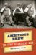 | Currently reading :  Ambitious Brew : The Story of American Beer  By Maureen Ogle  Release date: 02 October, 2006
11:27 AM - 1 Comments - 2 Kudos - Add Comment - Edit - Remove

Wednesday, October 25, 2006
Small revelation about getting older
Current mood: contemplative
Category: Life
I have always liked taking pictures, but I suppose it has been over the last few years that it has become more of a practice to document my travels and hobbies and post pictures on my website. I try to compose nice pictures, properly framed, maybe somewhat creative, etc.
Anyway, I do an ok job and I know my Dad enjoys the pictures I take. My Dad knows more about photography than I do. Back in his day, he had a dark room and developed many of his own pictures. Here is one of my mom and me.
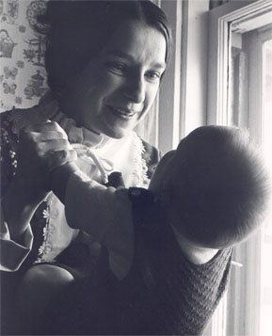
My dad still likes to take and share pictures: http://flickr.com/photos/ibike/
Recently he posted some nice Fall shots and I wrote back saying that they were very nice. He said that means a lot to him because he respects my ability to take pictures.
And then I thought.... huh? He respects my picture taking ability? He looks up to me in some way? He is the Dad. He is the older and wiser photographer. Do my comments really mean that much to him? I mean, I know I appreciate feedback. I like some validation when I make a web page and someone says "nice work." But surely my Dad is beyond needing such validation, right?
Well, maybe not. Maybe as you get older, even approaching 60 (sorry Dad), maybe you still appreciate being complimented. Maybe you still need people to say "yes, that is a good job you've done." I suppose it is natural to look at your parents a certain way probably for the duration of your life. But then I realized, I will be older one day too. When I am documenting my then-recent trip (to Europe?!) maybe I will still be wanting that person, maybe my daughter, to say, "hey dad, those pictures you took are pretty cool."
Thanks for saying that. Thanks a whole lot.
1:16 PM - 1 Comments - 2 Kudos - Add Comment - Edit - Remove

In the Year Two Thousand...
Current mood: satisfied
Category: Sports
A couple weeks ago I once again rode my 2000th bicycle mile in one season. I have done this for at least three seasons in a row. The vast majority of my miles come from riding to and from work. I've written about this in the past.
Anyway, I know some people ride more than that, but it's always satisfying for me to hit this mark. It's a lot of freakin bike riding, people. This season I will get up to 2100 or maybe 2200 miles in total.
Without all this bike riding, I could not consume nearly as much delicious, life-giving beer. I haven't figured out how many calories I burn on my commuting, but I know there is no way in hell I could drink the beer that I do without putting on weight without some other way to burn it off. It's awesome. I save gasoline, save money, get some exercise, and have thus far held off the oft-inevitable beer gut.
Anyway, drink a beer in my honor, beatches.

Friday, September 29, 2006
Pet Sounds on a rainy Fall morning
Current mood: content
It's been a hard week. Well, as hard as it can be for my job. You who know me know that my job is not particularly tough. But this week has overflowed with demanding customers, fussy laptops, and a full schedule.
Plus, I am sort of getting a little sick.
Plus, baby Evelyn has been waking up throughout the night, not always needing attention, but breaking up our sleep with a couple cries before she falls back asleep herself.
So it was about dang time that Friday finally rolled around. I have been biking all week even though it is cool in the morning with chance for scattered showers, and even though I was getting a little sick.
Today there was another chance for showers but I thought I would give it a try. Plus, I had a little something special planned for my last bike ride of the week.
Pet Sounds by the Beach Boys. Do you know it? You should. There is a reason nearly everyone from Sonic Youth to Elvis Costello to Paul McCartney claims it is one of the best records ever made.
Pet Sounds has recently turned 40 years old. I have probably been listening to it for about 10 years. I thought I should rip my stereo version to mp3 and listen to it on my bike ride to work. If I had to pick one album for my all time favorite, this would be it.
Now to the point.
I was biking to work on a cloudy, grey Friday morning. When I heard the opening harp strings of "Wouldn't it Be Nice?" I felt sunshine inside even if it was gray outside. After riding a little further, I felt a few raindrops. But then the luscious "You Still Believe in Me" started playing. I am a complete sucker for that song, especially the mountainous stack of vocals at the end. It's heartbreakingly beautiful, pretty much like the whole record through.
University Ave never felt so warm as it did this morning. Sure it started raining a little and splashing onto my work pants, but I was smiling, even singing a background vocal myself now and then. How many times have I listened to this record? How many more times in my life will I listen to it? I don't think it could ever get old.
So, rainy days aren't all that bad, if you got the sunshine down inside, suckas.
"I tried to prove how independent I'd grown now, but that's not me...."
3:46 PM - 0 Comments - 0 Kudos - Add Comment - Edit - Remove

Thursday, September 14, 2006
How to Spoil a Bachelor Party
Category: Dreams and the Supernatural
How to Spoil a Bachelor Party
Based on a true story...
1. Show up to a party where you hardly know anyone, any only recently have become friends with the groom.

2. When you arrive, immediately start talking loudly and require everyone to pay attention to you.

3. Use LOTS of swear words. Also, be vulgar, and say that you "need to see pink" when looking at a cleavage picture sent to your cell phone.

4. Betray your insecurity about your self and your obesity by growing a goatee. Must be done before the actual party date. [Note: goatees are so 1991. Get over them.]

5. Madly scarf down the food offered to you and do not even think about offering to help pay.

6. Throughout the night, continue to dominate the conversation, shaping it to reflect some pointless story of bravado or machismo.

7. Talk about how you allowed your young son to choose what he wanted for breakfast, and when he wanted Mountain Dew and cookies, you gave it to him.

8. Show off how cool you are by slamming cans of Coors Light, often within 15 seconds after opening. Then, throw the empty can on the lawn of the person hosting the party. Then, grab another one and repeat.

9. When you get sick of Coors Light, go into the cooler and take a craft beer that someone has brought for himself, and which someone would actually enjoy the taste of if you did not drink it. Open, take one sip, then bitch loudly "this tastes woody." [Note: that is called "flavor." By woody you are identifying the combination of hop bitterness and malt presence, both of which are absent in Coors Light.] Set unfinished craft brew on the lawn, unconsumed.

10. Slam another Coors Light.

11. Talk loudly and don't forget, SWEARING!

12. When your friend suggests for the 5th time that you really need to get going, make some crack about "those pu--ies can just wait" or something along those lines, and slam another Coors Light. By this time, everyone will really be sick of you and party will be pretty much spoiled. But don't quit yet!

13. Take time away from lifelong friends of the groom, and the stories they could be telling, the fun they could be having with each other, by holding sway over the group with riveting tales of your trip to Sturgis on your Harley.

14. Finally, after everyone is pukingly sick of your presence, pretend to leave, only to have the driver stop behind the house so you can reach into the cooler and take one more beer that you will not even enjoy tasting [Bells Two Hearted]. Climb into the car and drive of eternally into the night.
3:16 PM - 3 Comments - 2 Kudos - Add Comment - Edit - Remove

Sunday, August 27, 2006
It's Official - I am a Racist Bastard
Over years of living in my neighborhood, I have had at least three significant encounters with immediate neighbors. These shouting matches (they shout, I talk) have illustrated to me, in no uncertain terms, that I am to be hated for being a racist bastard. Some of these encounters have been written about previously, but not the latest one. While not all of them have explicitly called me a racist (one has), it has been implied in our conversations shouting matches.

1. Could you please turn down the music (at 3 am) a little?

This one goes back a few years. We had renters living immediately next to us. [Thankfully they got evicted and are gone now]. I dont know where people like that come from. They were often shouting in the back yard, sometimes into the wee hours of the night. But what really irked us was the loud booming music that would be played either from within the house, or from cars parked in front. Our bedroom was on the same side as their house, so if we ever wanted our window open in the summer we might be awakened in the night with loud music.

A few times I walked over and knocked the front door and asked them if they could turn it down a little. Sometimes they would. One night I went outside to once again see what the hell was going on, when I found a car parked in front of the house, probably around 3 am, with booming music. The passenger was just sitting in his seat. I asked him what he was doing and he said he was waiting for his cousin. I asked if he could turn the music down because, you know, people are trying to, uh, sleep around here. I dont really remember if he did or not, but what I remember was the next morning.

I was on my front sidewalk sweeping when the lady next door came out. She asked how are you doing rather snippily, and I said, well, Im kind of tired. Oh? Yeah, I couldnt sleep very well because of the loud music coming from a car that was parked in front of your house.

And then, it was on.

Huh? What are you talking about? Aint no car in front of my house playing music? Yes. It was exactly in front of your house. The guy said he was waiting for his cousin. You know, you people are always the ones complaining. Youre always coming over to our house or calling the police. What is it with you people and on and on.

It was beginning to come clear to me that, clearly, I did not like this person because she was black. I mean, the loud music and yelling and shouting at all hours of the night really had nothing to do with it.

2. Im just shoveling your alleyway driveway for you.

This encounter took place with my neighbor lady immediately across the alley from us this past winter. I snow blow the alley in front of my garage, and since she never lifts a finger to do any shoveling herself, I usually clear out the area in front of her garage too. We need that cleared so we can get our cars in and out of our garage. This particular time I cleared out the area in front of her cement slab where she parks her car outside too. Anyway, she came out and just laid into me. Admittedly, my snow blower throws the snow up against her garage door and kind of splatters it. She didnt like this one bit. I didn't think it was a big deal because that garage door never cracks the light of day. She blamed the snow for the paint peeling off the garage door, which had been like that ever since we moved in. I said I was clearing the snow out of the way so we could get our cars in and out.

I dont care was her reply. Well, you know, you never shovel so I have to do it for you. Thats your problem. And you cant come onto my property. This is my property and I dont want you here. I think the alley is city property. Ever since you people moved in, youre disgusting. Now it was getting funny. Were disgusting? Yeah. I hate you people!

WTF? This really took me by surprise. I mean, she hated me for shoveling her sidewalk, being a quiet, polite neighbor, mowing my lawn, raking, saying hi and all that?

You hate me? I just had to ask. I couldnt believe it. And, she said it again. Yes. I hate you. Damn. Well, that just about does it I must be a racist for being hated, and for trying to help her out with her snow.

3. Could you please not block our sidewalk if you must park in front of our house?

Last winter when my wife was getting increasingly pregnant, we decided to do something about the people always parking in front of our sidewalk entry onto the street. We dont park in front of our house that often, but when we do, it is nice to not have to climb through snow banks, especially for a big old pregnant lady. So, we started leaving very polite notes on windows please do not block our side walk so we can get into our cars more easily. Thanks. We did this a few times because there are a bazillion people living in this Hmong house, and we needed to get the message across.

Anyway, recently a white Honda was parked in front of our sidewalk again. I left another little note. The very next morning when there were NO cars in front of our house, and NO cars in front of their house, the same Honda parked smack dab in front of our sidewalk. Sure it wasnt a huge deal, but I had just asked her not to do that, again. So, I went out there to say hello and ask her if she could not park in front of our sidewalk. It was about 10:00 am on a Saturday. I have never heard so many F-bombs at that time of day in my life. I mean, it was you fking people always leaving your dirty notes. I have gotten like 4 of them now. [can you not read? Why dont you do what we politely ask?] I am so sick of you fking people. Im sure you would not leave notes if it was your white neighbors. You are fking racist. I dont want nothing to do with you, you fking bitch.

Whoa. I was still in my pajamas. I had not expected this.

Why are you so angry? I asked.

F this and F that and more Fs and a little F you thrown in for fun was basically what I got back.

I went inside and related this to Jamie. I mean, what is it with me? That is three different neighbors who have literally yelled at me. What do I do to people? Clearly it must be something. So, I have decided. I am a racist and all my peace-loving, calm, gentle, all-accepting neighbors can not tolerate my racist views. That must be it.

Later I baked cookies and Jamie too them and Evelyn over to the raging F-bomb slinger in an attempt at an apology [even though we knew we had no good reason to apologize.] Yeah, that did not work. More hostility and anger and so forth.

Thankfully most of our neighbors are awesome. We are often hanging out in one or anothers back yard, drinking beer, eating peanuts in the shell, and staying up to late, sometimes on week nights. Its a great stretch of the block that we live on. But, there are a few bad eggs, and they make it just ever so slightly uncomfortable to live in our house. Will they be out when we come home? What happens if I run into the snow blowing lady when I am leaving on a bike ride? What if the lady across the street parks in front of our sidewalk again [I can tell you, Im never leaving another note]. It puts us slightly on edge, and to be honest, it is a bit of a pity. Its a great house, and a decent neighborhood otherwise.

Of course, its my fault they dont get along with us. I mean, obviously Im a racist. Its probably baby Evelyns fault too, what with her drool and snide smiles.
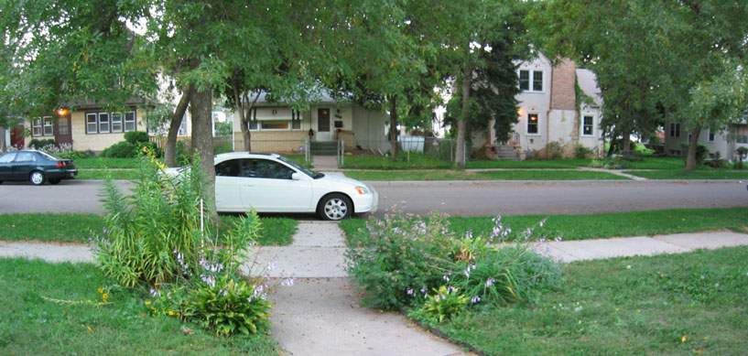
4:31 PM - 2 Comments - 0 Kudos - Add Comment - Edit - Remove

Friday, August 18, 2006
Soundtrack of our lives
Category: Podcast
Just a few things from this week.

1. He said it, not me.

"Male to male is never going to work. You always need a female in there." - Menards worker to woman looking for a garden hose adapter.

2. The soundtrack of our lives.

The other day while biking home, listening to my music, a guy jaywalking had the nerve to yell at me "wrong side!" when I nearly clipped him (on purpose) because he failed utterly to look in my direction to see if there were any oncoming cars or bikes. He was referring to the bike lane on the left side of the one-way street. Since I, however, make a right turn, I ride on the right side of the street. I am fully within my legal rights. There is no law I know of requiring a biker to ride in a bike lane when such a lane in present. Usually I would ride in those lanes but it makes no sense if I am turning the other way.

Anyway, this tubby, twenty-something had his music on too, and he yelled at me. I said back, "you dont know what youre talking about. I can ride here. How do you know where Im going?" He then sort of mumbled again "you have to ride on the other side." I pointed out its not a requirement. We went back and forth briefly, but the funny thing is, I could not really hear everything he said, because of my music. Then I thought, huh, maybe he can't hear what I'm saying. And there we were -- two grown fellas having an interchange, not even listening to each other.

I had a similar thought yesterday while in line to buy a sandwich. One person had their headphones on while in line for lunch. The next person had a Blue Tooth thingee on her ear. I thought, does anyone ever talk to someone next to him any more? Do we withdraw into our worlds of headphones and cell phones, and isolate ourselves from the nearest breathing human? Well. We do.

3. Quiet, warm baby.

Despite the asshole yelling at me as if he knows everything, as if he decides for the world what is right, wrong, and how it should revolve, the day contained a moment of peace, quiet, and contentment. Jamie had gone out for a walk and I was watching four-month old Evelyn. She was pretty tired at one point so I took her upstairs to a quiet room to rock her to sleep. I held her to my chest, swayed quietly back and forth, and hummed and sang a few quiet songs. At that moment, that was all that mattered. The chores, the traffic, the Ipod and cell phone people, the dude yelling at me, all of it was gone. It was just my little warm quiet baby drifting off to sleep, hugging closely to her Dad.

So. Life is good.

</P< A>

 | Currently reading :  The New Pearl Harbor: Disturbing Questions About the Bush Administration and 9/11  By David Ray Griffin  Release date: March, 2004
9:38 AM - 1 Comments - 2 Kudos - Add Comment - Edit - Remove

Saturday, July 29, 2006
"...as I climb into my f--king SUV..."
At least he was honest. I was standing by the elevator to get down to the parking garage so I could bike home from work. I was holding two pannier packs, had sunglasses on top of my head, was wearing biking shoes and gloves, AND had a dorky reflective vest on. So the guy says to me, he says, "you biking?"
"Uh. Yeah."
"How far do you have to go?"
"Little over 9 miles."
"well, that's not too bad then," he said with enough seriousness to make it sound like it was nothing. I mean, a breezy 9 mile ride in 90 degree weather. Who couldn't handle that?
And then, he brought in a dose of reality. "Ha, yeah, look me at me, saying that, as I climb into my f--king SUV." I smiled. I liked that. That's right fella. You climb into your coffin and sit on the freeway while I will coast underneath trees in the shade. Ha, that sounds a little more idyllic than it actually has been, since it's been 90 degrees for 3 weeks.
Anyway, some of you have seen my bicycle commute page, but if not, thar she blows: http://www.donosborn.com/bike_ride/bike_ride.htm
10:39 AM - 0 Comments - 0 Kudos - Add Comment - Edit - Remove

Wednesday, July 19, 2006
Found a picture in the garbage
Category: Religion and Philosophy
Due to the impending rain I rode the bus today instead of biking. At the bus stop there is a post into which people throw garbage. On the top of the pile I saw a picture. I grabbed it and thought it was interesting how many things I could surmise about the people related to the picture just from looking at it. Here it is. Some thoughts below...
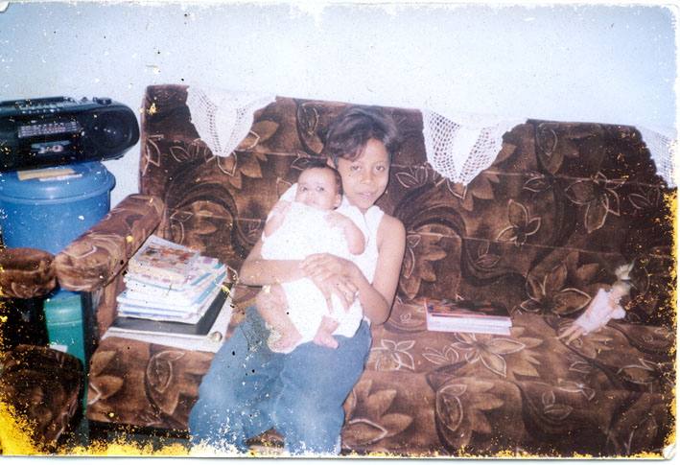
1. The date on the back of the picture says 2002, but the couch looks pretty dated and worn. Makes me think these people don't have a lot of money.
2. The two plastic storage bins stacked in the corner might be because the apartment (?) does not have a lot of space.
3. The old boombox makes me think again that money might be kind of tight.
4. The stack of books and notebooks looks like there might be a student in the household, maybe an adult going back to school to get educated in hopes of changing careers.
5. The children in the picture have some color, but the Barbie doll is white. The doll also looks kind of 80's. A Goodwill buy?
6. Despite the apartment living (?) and perhaps tight money (?), the family has children. I like this. Money is not everything and we could all do with less, especially when it is necessary to make cuts to be able to get food on the table.
These thoughts could be completely wrong, and I suppose they are somewhat stereotypical. Another thought I have is that there is a large apartment building nearby in which a lot of Somalis live. I can't help but wonder if this came from one of those families.
Just a little random thing to add to your day.
1:02 PM - 1 Comments - 0 Kudos - Add Comment - Edit - Remove

Thursday, July 06, 2006
Bombs Bursting in Air
It had been several years since I had seen a proper, gosh-darn, big ol American fireworks display on the 4th of July. For most of those years I was out of the country on the 4th. One year I was in Duluth but the fireworks got rained out. So this past 4th of July I was thinking I should get down to Harriet Island in St. Paul to see the big show. Trouble is, I couldnt round up anyone to go with me. Being one for adventure, I decided to pack up a few things and head off by myself on my bike.
Moving through residential neighborhoods, there were fireworks going off all around. One street was blocked off, perhaps for a block party. There were children and parents on sidewalks and in driveways lighting of lots of small fireworks. There was a festive mood lingering. Once I got to Summit Ave and got closer to the Cathedral, cars got thicker. Soon I was making way better time on my bike than the cars, passing them on the side as they sat idling in their coffins.
Jamie had suggested I watch from the Cathedral but I wanted to really get in on the action. Once downtown, cars and people were everywhere. I mean, its hard to explain. Hanging on railings, crowding bridges, standing on the sidewalk. Cars were backed up, unable to move forward or backward. I had to walk my bike over the bridge, and the crowd was thicker than ever. I forgot how many thousands and thousands and thousands and thousands of people go to this thing.
Finally I made it to the island, but once I was about to get into the main area, I was told I could not bring my bike. I had only brought with me a wimpy lock, and I did not trust it to keep my bike safe if I was to leave it behind. It dawned on me that I had to get back off the island if I was going to be able to watch the fireworks with any sort of comfort, that is, not standing with about 2 million other people jam-packed on a bridge. I began crossing the bridge again when they started going off.
I ended up biking through downtown and back up Cathedral Hill when they were going. I glanced over my shoulder from time to time to see explosions in the sky. I would pause in different city parks for a moment and then continue the ride. Eventually I got to a grassy hill just across the street from the Cathedral. I set my bike down and finally could relax. There were a number of other people on the hill watching.
Maybe it was the homebrewed cider I brought along to drink, or maybe it was the hand-rolled cigarettes I was smoking, but the fireworks seemed, um, extra pretty or something. Most likely it was just because I hadnt seen any for so many years. But laying on the grass, looking up at the flecks of light bursting in color, hearing the booms and crackles, it was what I came for. At one point I closed my eyes and could more clearly hear the deeper booms echoing off the cathedral first, and then on an apartment building on my other side. It was like hearing the sound 3 times. With the loud booms and the popping glitter crackles, for a moment I imagined I was in a war zone (NOT like I ever have been, of course). I could imagine mortar rounds being launched and spitting machine gun fire. I thought I would open my eyes and get back to reality.
Maybe the slightly altered state I was in tied it all together. It's not necessary of course, but it helped along a fine summer night. I could see it becoming an annual thing, except Id have to head down a whole lot earlier than 9:30 if I wanted to get a good spot on the island. And of course, leave the car at home. A bike would be the only way to go.
3:58 PM - 0 Comments - 0 Kudos - Add Comment - Edit - Remove

Wednesday, July 05, 2006
Ashes of American Flags - Wilco rocks Duluth
Current mood: refreshed
Category: rocked Music
When I heard that Wilco (one of my favorite bands) was going to be in Duluth (free lodging at the in-law's) over a holiday weekend (free time-off from work), and when I realized I had not gotten off my butt and seen them for 10 years, I knew I had to buy tickets. I saw Wilco around the time Being There was just about to come out, but I hadn't seen them since. It took me a number of years to come to a mature love of Summerteeth, Yankee Hotel Foxtrox, and A Ghost is Born. But now that I like those records, I really like them. And so Wilco has quietly become one of my favorite bands, supported in no small way by all the kick-ass bootlegs I have downloaded over the years. The official live release Kicking Television is a wonderful summary of what the band is like in concert.

And maybe it's almost too good of a summary. That is, the setlist for the show last Sunday drew generously from the Kicking Television track list. Not only that, but versions of the songs used the same little tricks, like the much-repeated "nothing!" at the end of "Misunderstood" to the call-and-response of "how can I?...[Tweedy]..." "blaaaahhhhh![crowd]" in "Kingpin." I couldn't help but thinking if Kicking Television would have also been released as a concert film as was originally intended, I might have felt slightly ripped off. I love me some Wilco, and songs like "Handshake Drugs," "At Least That's What You Said," "Ashes of American Flags" and so many more, are going to rock your socks off and thrill you no mater how many times you see or hear them live. But I thought they would throw some more new stuff at us.

One song that was new to me, but that I read somewhere might be a B-side from a few years ago, seems to go by the name "The Good Part." It was a fine song, and so was Walken, a new song, but one I had heard on bootlegs before last Sunday. In concert that song packed even more rock punch.

There were songs I didn't expect to hear, but were pleasant surprises. "Theologians" has to have one of their best and catchiest opening lines. "Far, Far Away" was a quiet ushering into the rest of the set after the pounding ending of "Misunderstood." "Forget the Flowers" was something I was not expecting either. Another pleasant surprise was the moment the lights went down for Wilco, everyone stood up from their cushy and comfortable auditorim seats, and did not sit down until it was over. The place was packed from what I could see (lower level, I could not see the balcony) and the crowd was very into it. That helped the overall energy and enjoyment (at least for me) of the show.

It's been a while since the last recorded release, and I just felt they could have thrown us a few more new songs, or at least something unique. It was their first time in Duluth, Tweedy is a huge Dylan fan, so how about a cover? Or at least "Bob Dylan's Beard"? Nope. Still, you can not deny how massively awesome Wilco is, especially live. Spiders (Kidsmoke) just about tore the roof off, and ending a concert with the trio of songs "Heavy Metal Drummer" (complete with the great oooh oooh's and ahh ahh's), the heavy riff of "Kingpin," and the confusingly-feel-great "The Late Greats," well, not every band can do that.

Guys put out a new record, and for the love of God come back to MN. Ill be there.

Pictures: http://frozensecond.smugmug.com/gallery/1627948

Setlist: 1 hour 50 min

Misunderstood
Far, Far Away
Handshake Drugs
I Am Trying To Break Your Heart
The Good Part (?, new song)
A Shot In the Arm
At Least Thats What You Said
Jesus, Etc.
Walken (?, new song)
Theologians
Im the Man Who Loves You
Ashes of American Flags
War on War
Hummingbird
(Encore 1)
In a Future Age
Spiders (Kidsmoke)
(Encore 2)
Airline to Heaven
Forget the Flowers
Heavy Metal Drummer
Kingpin
The Late Greats
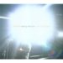 | Currently listening :  Kicking Television: Live in Chicago  By Wilco  Release date: 15 November, 2005
4:33 PM - 0 Comments - 0 Kudos - Add Comment - Edit - Remove

Monday, June 26, 2006
Most Likely to Succeed
Current mood: content
Category: Life
My Fifteenth-Year High-School Reunion is coming up at the end of the summer. This has made me think about some of my high school days. One of the memories I have is of Awards Night. Not only is this the night where I collected copious scholarships (I was Valedictorian, if you don't know. That fact is relevant to the rest of this column), but it was also the night of the more entertaining (and sometimes life-long scarring) "best of" awards voted upon by one's classmates.
I must have done something right, or perhaps wrong, because I pulled in a few of these "best of" or "most likely to" awards. I mean, obviously, I won Best Butt. Just kidding. Mike Schmidt won that. I think I won three, but I can only remember two right now. The first was "Most Conservative." Now, some of you who know me now might think that makes some sense. However, in 1991 it made no sense. I was a skateboarder, a free style biker, and I had bleached, long hair. This was before X Games and snowboarding as an Olympic sport. This was in a 2,400 population small town. I got ridiculed for my hobbies and appearance. Of course, I knew I was cool. Also, I was in a rock band. This was before everyone you knew was in a band, too. I think out of our whole high school there were two bands. So, most conservative? It had nothing to do with politics. I don't think the terms conservative and liberal were even in the Amery High vernacular. That title is still one that sticks in my craw, mostly because I can never figure it out. I should ask my classmates at my reunion this summer!
The other award I received, probably because I was a smarty pants, was "Most Likely to Succeed." It was this memory that I've been mulling over because, well, I'm going to my reunion soon. I've had fifteen years. Have I friggin' succeeded or have I not, for God's sakes?!
As a starry-eyed, world-in-front-of-me-for-the-taking High School senior, that word meant something pretty specific. I'm talking greenbacks. I wouldn't say that money was all I valued, but I think that both my class and myself thought that success would mean making a decent amount of money.
So, am I successful, fifteen years later, did I succeed in living up to my classmates aspirations for me? Well. Hell yes I have. But maybe not in the same way as they or I expected me to.
Success has a different meaning to me now. I'm sure it does for most of us when we think of what we were like at 18. But now, I value a safe and healthy family. I have a beautiful wife and a darling daughter. My marriage of 10 years is as strong as ever. Most of my siblings live within striking distance, and we actually stay in frequent touch and enjoy hanging out.! Our parents are not far away, and they are healthy. My home is wonderful and (usually!) quite safe, especially if I lock the windows at night. We have traveled Europe a number of times and created fantastic memories. I have many great friends to do things with. I am surrounded by decent neighbors, friends, family, books, kegs and kegs of delicious homebrew, and even a small back yard in which to sit, read, and enjoy a glass of crystal clear Helles lager. I mean, really, is that not success? I dont make tons of money and we are voluntarily now down to one income, but we pay the bills, and we have what we need. Actually, we have so much more.
3:49 PM - 3 Comments - 2 Kudos - Add Comment - Edit - Remove

Tuesday, June 20, 2006
Don’t forget to steal the olives
Current mood: aggravated
Category: Games
So around 2:30 am last night Jamie wakes me up. No, not a problem with Evelyn, thankfully. That trooper slept through this entire ordeal. Anyway, somebody is in the house, Jamie says. Great.

Quickly we start running through scenarios. Methd-out loser looking for cash? Psycho killer looking for some fun? Jamie had heard a loud crash and that is what woke her up. Then we heard the phone in the dining room fall to the floor, and then the beeping. So we knew we couldnt call for help from the upstairs. Cupboards were being opened, drawers pulled out. Our cell phone is always downstairs somewhere.

We didnt know if we should make noise to scare away the intruder, ala a black bear kind of thing, or if we should be quiet and let him/them take what they want and then leave. They were making a fair amount of noise, opening cupboards, etc, so it seemed like they did not think anyone was home, even though the light was on in the downstairs hallway, and we had fans pulling in cold air. My computer was on too. Isnt that enough of a sign that people are home? That combined with the phone "being taken" off the hook (we suspected) made us wonder if they were capable of harming anyone in the house. It got to be pretty freakin' scary for a while.

Jamie had the idea to move a dresser in front of the door at the top of the stairs. That would keep the intruders from coming upstairs. But, it would also let them know that people were in the house. So if they had malicious intentions, we would have to do it before they climbed the stairs and bashed the door in. I tell you, I hope you are never in that situation. We cleaned off the dresser quietly and got ready to move. Then, we moved that sonofabitch in front of that door faster than any moving company. We probably moved it 20 feet. You know how far our outside wall is in our bedroom to the top of the stairs.

At that point it got real quiet downstairs and I figured they/he had left. Still, we didnt want to go downstairs to find them hiding in a closet. Then, totally randomly, Jamie remembered she had the cell phone in the diaper bag because she had taken Evelyn out of the house that day, and the bag was upstairs. I called 911 and within a few minutes the police were walking around the house. The front and back doors were open so they just walked in. They had a dog too. I told them we had cats and they said they would watch the dog. No one was in the house any more and they had us come down from the upstairs.

Then the assessment began. The first thing we noticed were some frozen pizzas near the door. The bastard was trying to make off with some of our food, too. Then I saw my empty wallet sitting on the dining room table, my ~$15 cash and all credit/insurance cards were gone. Nice of them to leave my drivers license at least. Also, the digital camera is gone. I have all of the pictures off of it on my hard drive or cds at least. Next (and this is kind of the saddest part) about $100 in cash gifts we had received for Evelyn was gone. Normally I would have deposited this money, but I just kept it in an envelope thinking we could go buy something for her sometime, clothes, whatever. I wasnt thinking, I better not keep much cash in the house in case were get broken into The last thing of value to be stolen was my Ipod. All in all, we lost around $700 worth of stuff.

Oh yeah, the olives. The guy had taken an olive jar out of the fridge, completely ignoring the sandwiches, lunch meat, cheese, veggies, and fruit in there. There was probably ½ cup or more of olives left, and they were all gone, except for one on the floor, and one in the bottle. Huh. The police took the jar and my empty wallet as evidence. They might look for fingerprints but I doubt that will lead to an arrest.

Meanwhile Evelyn sleeps through the whole thing.

We called the bank and credit card companies and took care of as much of that as we could think of. No charges had come in as of that time.

Some odd things, I think. Both bikes were not touched. I was particularly relieved about that. My bike is my daily tool to get to work and all the gear and time I have put into it, it would have been a pain to replace. They did not take any cds. They did not take any checks, either (even though we have cancelled all those). They did not take my Wilco tickets that were sitting underneath the Ipod. J They did not take any guitars, dvds, stereo equipment, or computers. I am guessing they were on foot. Then again, how do you explain the frozen pizzas? Makes me think they live close enough to be able to get them home and cook them? I dont know. Maybe there was a car to pick them up.

We got to bed maybe around 4:30 and I kind of laid awake until about 6:30. I called work and told them Id be a couple hours late. Got up around 8:30 for that.

Around 5:00 Evelyn began to wake up. She had slept for 6 hours. What a good little precious baby! We were most thankful that she and all of us were safe.

OK, about the break in. Its stupid, we know. We always lock all doors, and for the first few years of living at that location, we also locked all windows at night. Eventually we started leaving one or so open. Well, now we leave them all open. Its nice to get the cool air into the house at night. The intruder(s) came in through the office, the back yard window. They grabbed my orange Home Depot bucket to stand on, broke a screen and then came in. They probably grabbed my Ipod and the cash right then.

We dont know how the back door got unlocked. I am 100% sure it was locked because I had brought some laundry in around 8:30 that night and locked it. He/they might have gone downstairs and opened it to let another person in. Not sure how many people were in our house. I am guessing they were only in for 5-10 minutes. Seemed like longer. Maybe only 5. Im sure Jamie heard them pretty soon as they were in, maybe when they broke the screen even. At that point we quickly started thinking of what we should do. We figure they left out the front door as it was open too, and that is where the pizzas were dropped.

While the police were still at our house they said another break in was happening on Charles 2 blocks down. Could have been he same guy(s). We have not heard that any of our stuff was found and I doubt well see it again. I dont know if I will file an insurance claim. We have a $500 deductible and the value of the stuff would not me a whole lot more than that. I dont want our premium to go up for only a couple hundred $. I will probably call at some point. Anyone know if you can get reimbursed for cash?

So, it could have been a whole lot worse of course. But still. Who the hell wants people breaking into your house and going through your stuff and robbing you when you and your baby are upstairs? Lesson to us: every window has to be closed and locked. Kind of stinks but it has to be done. I havent looked into it, but Im guessing the vast majority of these types of break-ins take place when a door or window is unlocked. I doubt a person like that would break glass or try to pry a door open to get in. At least, that is my suspicion. They are looking for quick and easy cash, not really to go through a big hassle to get in, or not really wanting to harm the people. At least that is my hope.

So, one car stolen and one house broken into. Not bad for 5.5 years on the block.

Talk to you later,
Don

Thursday, June 01, 2006
Dedicating my life... to good beer
Current mood: Content
Isn't that what it's all about? Not just beer, but the good things in life. I mean, tonight a friend and I went to a local watering hole with one of the best tap selections in St. Paul/Mpls (Happy Gnome) to try a couple of newly released local offerings. The first was Summit's Scandia, a sort-of Wit bier. It had a decent citrus flavor, was quite quaffable, and was a perfect compliment for a nice summer afternoon while sitting on the patio. We tossed the lemon slices - who needs them?
Next was Surly's latest, CynicAle, a Saison of sorts. It could be called an American Saison I suppose because the hops were more present than a traditional one. There was some kind of mild dark caramel flavor lingering in the back of the throat, not sure if we liked that or not. But otherwise, the Belgian yeast (?) gave it a unique flavor and our hats were off to them for offering it as one of their regulars. It is definitely not your run-of-the-mill regular beer lineup (think Summit EPA, Leinie's Original, etc). They are being bold, sticking to the namesake of the brewery, taking chances.
We can do the same too. Don't just drink macro swill. Don't just watch the TV or movies they feed you. Change the radio dial and look for something different. Make a pizza from scratch. Be your own person, don't 'cha know? You bet'cha.
And, uh, keep an eye out for that rare and delicious beer...
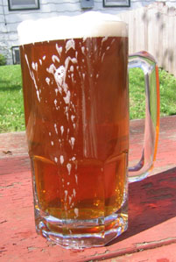
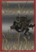 | Currently reading :  The Satanic Verses  By Salman Rushdie  Release date: 22 February, 1989

